


Zagazig University
Faculty of Computers and Informatics Computer Science Department

Ru'yaAi
AI-Powered System
For Intelligent Crowd Management and Analysis

BY
عاصم احمد محمد عبدلله
محمد السيد محمد اسماعيل
محمد وحيد محمد فهمي
محمد سعيد محمد ابراهيم صقر
ابو بكر علي فتحي اسماعيل
عبدالرحمن فتحي توفيق محمد
شادي اشرف محمد عبده منصور

Under Supervision Of
الدكتور/ محمود مهدي
2024-2025

ABSTRACT

Crowd counting and monitoring are important challenges for cities, public spaces, and large events. Traditional ways of monitoring crowds are often manual, time-consuming, and not accurate enough to help make quick decisions in busy or changing environments. In this project, we developed Ru’yaAI, an AI-powered system that uses modern computer vision techniques to count and monitor crowds in real time.
The main objectives of this project are to: (1) implement state-of-the-art computer vision techniques for precise crowd density estimation, (2) develop a comprehensive web-based and mobile application to monitoring platform for real-time visualization and management, (3) integrate intelligent alert systems for proactive crowd management, and (4) provide historical analysis capabilities for data-driven decision making.
One of the key features of Ru’yaAI is that it can handle live streams from cameras or YouTube, detect motion, send smart alerts when crowds become too large, and save data for later analysis. The system is flexible and can be used in places like shopping malls, schools, transport stations, or large public events.
By combining advanced AI with a simple interface, Ru’yaAI makes it easier for security teams and event organizers to understand crowd situations and take action when needed. This project shows how modern computer vision research can be turned into a practical tool that helps improve safety and management in real life.

1. Introduction
1.1 Introduction and Significance
1.1.1 The Challenge of Modern Crowd Management
In an increasingly urbanized world, effective crowd management has emerged as one of the most critical challenges facing public safety officials, venue operators, and urban planners. The rapid growth of global urban populations, with the United Nations projecting that 68% of the world's population will live in cities by 2050 [1], has intensified the need for sophisticated crowd monitoring solutions. Large gatherings in public spaces, transportation hubs, commercial centers, and special events pose significant safety risks when overcrowding occurs, making real-time crowd density monitoring not just a convenience, but a necessity for preventing potential disasters.

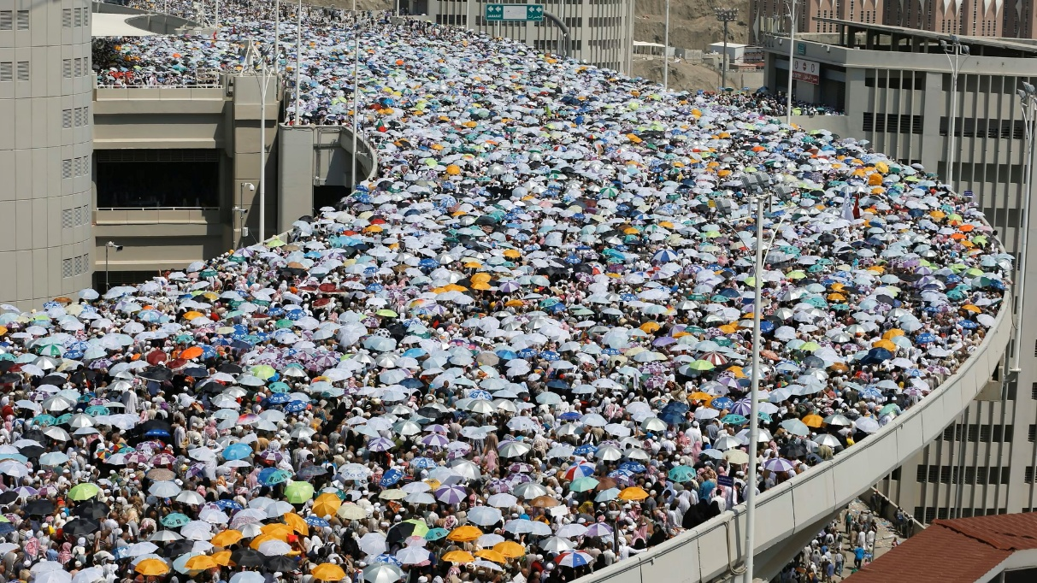
The significance of this challenge becomes starkly apparent when examining real-world incidents of crowd-related disasters. For example, the 2015 Hajj stampede stands out as one of the deadliest crowd disasters in modern history, resulting in more than 2,100 deaths, as reported by Associated Press and Reuters and analyzed in Archives of Trauma Research (Salamati & Rahimi-Movaghar, 2016). This tragedy was not an isolated incident — stampedes have repeatedly occurred during Hajj over recent decades. For example, past events include 1,426 deaths in 1990, 270 in 1994, and 360 in 2006, underscoring the recurring nature of this hazard for millions of pilgrims [2].
Figure 1.1: The Hajj Stampede

1.1.2 Current Limitations and Real-World Impact
Traditional crowd management approaches rely heavily on manual observation by security personnel and static surveillance systems, which are inherently limited in their effectiveness. Human observers are prone to fatigue, subjective interpretation, and cannot provide consistent 24/7 monitoring across multiple locations simultaneously. Moreover, manual counting methods are notoriously inaccurate, with studies showing error rates of up to 30% in high-density scenarios. Static camera systems, while providing visual coverage, lack the intelligent analysis capabilities needed to automatically detect dangerous crowd conditions or predict potential overcrowding situations.

The economic implications of inadequate crowd management are substantial. According to Market Data Forecast, the global crowd management systems market was valued at approximately USD 1.90 billion in 2024 and is projected to reach USD 10.10 billion by 2033, growing at a robust 20.4% compound annual growth rate from 2025 to 2033. This rapid market expansion reflects the escalating demand for advanced, intelligent crowd-monitoring technologies. Event organizers and public venue operators now face significant liability exposure along with potential reputational and regulatory repercussions when crowd incidents occur [3]
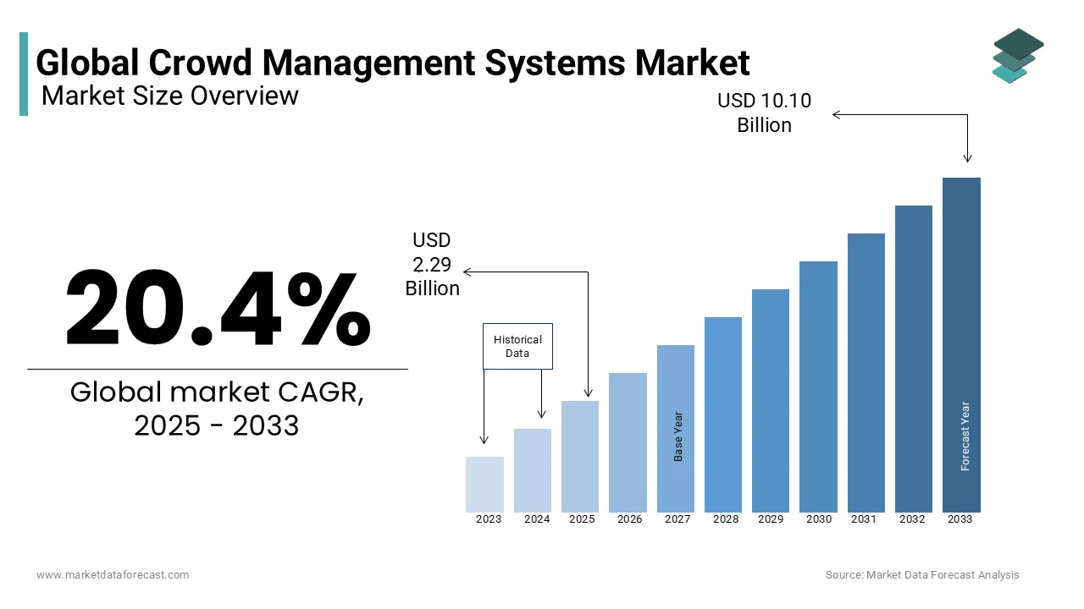

Figure 1.2: Global Crowd Management Systems Market

1.1.3 Project Objectives and Innovation
This project addresses these critical gaps through the development of an intelligent crowd density monitoring and analysis system that leverages cutting-edge artificial intelligence research combined with practical software engineering to create a comprehensive, deployable solution.
The primary objectives of this research and development initiative are:
1. Advanced Accuracy and Reliability: Implementation of the CLIP-EBC (CLIP Enhanced Blockwise Classification) methodology
2. Real-Time Processing and Scalability: Development of a robust backend architecture capable of processing multiple concurrent video streams in real-time, providing immediate crowd density analysis with visual feedback including density maps, motion detection overlays, and accumulated heatmaps. The system supports both live streaming sources and recorded video analysis, ensuring flexibility for various deployment scenarios.
3. Comprehensive User Experience: Creation of an intuitive, responsive web application built providing administrators with comprehensive dashboards for monitoring multiple locations simultaneously. The platform includes zone management capabilities, configurable alert thresholds, historical trend analysis, and detailed reporting functionality.
4. Cross-Platform Accessibility: Integration of mobile application capabilities ensuring that crowd monitoring and management can be conducted from any device, anywhere, providing critical mobility for security personnel and venue operators.
5. Intelligent Alert and Analysis Systems: Implementation of proactive monitoring capabilities that can detect potentially dangerous crowd conditions before they become critical, including real-time crowd counting based on model output, comparison against a defined maximum threshold, threshold-based alerting, motion pattern analysis, and predictive density modeling.
1.2 Contribution to Scientific Discovery
1.2.1 Innovative Technological Integration and Architecture
The project's most significant innovation lies in its holistic approach to crowd monitoring system design, integrating cutting-edge research with practical deployment considerations. The development of a real-time processing pipeline that seamlessly combines deep learning inference with live video stream processing represents a novel contribution to the field of real-time computer vision applications.
Multi-Platform Ecosystem Innovation: The creation of a comprehensive ecosystem spanning web applications, mobile platforms, and cloud infrastructure demonstrates an innovative approach to scientific application deployment. The React-TypeScript web application (ru2ya platform) integrates modern front-end technologies with real-time data visualization, while the complementary Flutter mobile application ensures cross-platform accessibility. This multi-platform approach represents a significant contribution to the understanding of how research-grade AI models can be effectively deployed across diverse user interfaces and interaction modalities.
Real-Time Processing Architecture: The implementation of FastAPI-based backend services with GPU acceleration and concurrent stream processing capabilities contributes to the field of scalable AI deployment. The system's ability to process multiple video streams simultaneously while maintaining real-time performance benchmarks provides valuable insights into practical deployment strategies for computationally intensive computer vision applications.
Motion Detection Integration: The novel integration of Structural Similarity Index (SSIM)-based motion detection with crowd counting algorithms represents an innovative approach to comprehensive crowd behavior analysis. This multi-modal analysis framework contributes to the understanding of how different computer vision techniques can be synergistically combined to provide richer contextual information for crowd management applications.
1.2.2 Industry and Practical Impact
Smart City Development: The project's contributions extend beyond academic research to practical smart city applications. The demonstrated integration of AI-powered crowd monitoring with existing urban infrastructure provides a blueprint for large-scale deployment of intelligent surveillance systems. The system's ability to handle diverse video sources, from CCTV networks to streaming platforms, demonstrates practical applicability to real-world urban monitoring scenarios.
Public Safety Innovation: The research contributes to the emerging field of AI-powered public safety applications by demonstrating how sophisticated computer vision models can be deployed for proactive crowd management. The implementation of configurable alert systems, threshold-based monitoring, and historical trend analysis provides valuable insights into practical requirements for public safety applications of AI technology.
Event Management Technology: The project contributes to the entertainment and event management industry by providing empirical evidence for the effectiveness of AI-powered crowd monitoring in real-time event scenarios. The system's capability to process live streams and provide immediate feedback represents a significant advancement in event safety technology.

2. Related Work
2.1 Existing Approaches to Crowd Counting
Crowd counting methods have evolved significantly, progressing from traditional detection and regression frameworks with hand-crafted features to advanced CNN-based and vision-language-based models. Broadly, these methods can be divided into four main categories: detection-based, regression-based, traditional density estimation, and modern CNN-based density estimation, including recent classification frameworks and emerging vision-language techniques.

2.1.1 Detection-Based Approaches
Early crowd counting research primarily adopted detection frameworks. These approaches used sliding windows to detect visible body parts — mainly heads and shoulders — in crowded scenes [4–6]. With the advent of deep learning, modern CNN-based object detectors have largely replaced hand-crafted feature detectors, improving detection accuracy in sparse scenes. Notable examples include two-stage detectors like RCNN [7], Faster-RCNN [8], and Mask-RCNN [9], as well as one-stage detectors like YOLO [10] and SSD [11].
However, while these methods perform well for sparse crowds, they degrade under heavy occlusion, severe clutter, or extreme crowd densities due to difficulties in distinguishing closely packed individuals.
2.1.2 Regression-Based Approaches
To address detection challenges in dense scenes, researchers reformulated crowd counting as a regression problem, learning a direct mapping from image patches to global counts or density maps. Early works relied on extracting low-level local features — such as SIFT, HOG, LBP — or global features like texture and gradient. Classical regression techniques included Gaussian process regression, linear regression, and ridge regression.
While these methods handled dense crowds better than detection-based approaches, they often discarded fine-grained spatial information necessary for precise localization.
2.1.3 Traditional Density Estimation
To preserve spatial context, traditional density estimation frameworks emerged. Lempitsky et al. proposed learning density maps where the integral over any region directly yields the crowd count, circumventing explicit detection. This approach framed density estimation as a convex quadratic optimization problem.
To tackle the non-linear relationship between features and density, Pham et al. extended this by using random forest regressors, introducing a crowdedness prior to handle large variations in appearance. They also proposed forest reduction techniques for real-time inference with lower memory footprints.
Despite these advances, reliance on hand-crafted features limited the representational capacity for complex scenes.
2.1.4 Modern CNN-Based Density Estimation
The success of convolutional neural networks (CNNs) in vision tasks led to extensive research in CNN-based crowd counting. CNNs enable end-to-end learning of highly non-linear mappings from raw images to detailed density maps, outperforming traditional approaches in scale variation, occlusion, and background clutter handling.
Well-known models include CSRNet [12], which leverages dilated convolutions to expand receptive fields without losing resolution, and DMCount [13], which introduces distribution matching for robust scale variation handling.
These models produce continuous density maps, allowing for more accurate estimates in highly dense and unconstrained scenes.
2.2 Blockwise Classification Frameworks
To handle the long-tail distribution of count values — from sparse to extremely dense crowds — recent work has shifted towards blockwise classification frameworks. Instead of regressing continuous densities, these methods partition an image into local blocks and classify each block into discrete count bins.
Standard Blockwise Classification (SBC) [14] and DCNet [15] introduced discrete binning and probability maps to improve robustness in high-density scenarios. These methods mitigate regression drift but introduce new challenges:
- Reliance on Gaussian smoothing can distort labels.
- Ambiguous predictions arise at bin borders, harming performance near bin edges.
2.3 Vision-Language Models in Crowd Counting
The emergence of vision-language models marks a new frontier in crowd counting. OpenAI’s CLIP (Contrastive Language-Image Pre-training) model [16], trained on massive image-text pairs, excels at zero-shot image classification and cross-modal understanding.
However, CLIP’s natural language alignment and global feature representation present unique challenges for dense counting tasks. Notable adaptations include:
- CrowdCLIP [17], which uses global CLIP image features for unsupervised total count estimation but struggles with capturing local density variations.
- CLIP-Count [18], which augments CLIP with custom decoders to produce density maps, though this adds complexity and dependency on external modules.
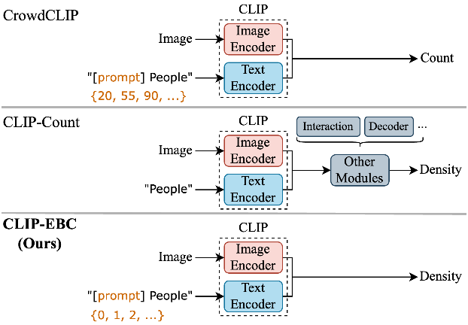
These works highlight the potential of prompt-based crowd counting but underscore gaps in fully leveraging CLIP’s discrete-text alignment for local, blockwise counting.

Figure 2.1: Comparison of our model CLIP-EBC and other CLIP-based crowd counting methods
2.4 Limitations in Current Research
Despite substantial progress, several key limitations persist:
- A mismatch between discrete label spaces and continuous density estimation persists, especially when using vision-language models like CLIP, which naturally handle discrete tokens.
- Label ambiguity near bin edges in blockwise classification reduces prediction reliability.
- Ground truth maps for high-density scenes often contain annotation noise, degrading model generalization.
- Many solutions depend heavily on additional decoders or modules, complicating deployment and deviating from CLIP’s native zero-shot, prompt-based strengths.
2.4 How Ru’yaAI & CLIP-EBC Address These Gaps
Our project integrates CLIP-EBC [19], the first fully CLIP-based density map crowd counter: The CLIP-EBC approach implemented in this project represents a significant departure from traditional density map regression methods by treating crowd counting as a classification problem enhanced with language understanding capabilities. Unlike previous approaches that rely solely on visual features, CLIP-EBC leverages the multimodal understanding capabilities of CLIP to improve counting accuracy through enhanced contextual understanding.
The CLIP-EBC approach leverages pre-trained vision-language representations that have been learned from massive datasets. This fundamental difference enables superior generalization capabilities and reduced dependence on domain-specific architectural engineering.
- It introduces the Enhanced Blockwise Classification (EBC) framework, solving bin ambiguity via integer-valued binning, reducing label noise through noise thresholds, and adding a Distance-Aware Cross-Entropy Loss (LDACE) that aligns classification with regression accuracy.
- Unlike CrowdCLIP and CLIP-Count, CLIP-EBC remains backbone-agnostic and modular: it only fine-tunes minimal layers while keeping CLIP’s text encoder frozen for robust prompt alignment.
- Ru’yaAI system takes this model further by building a real-time web & mobile platform, integrated live dashboards, proactive alerts, and historical analytics — bridging lab-level breakthroughs with field-ready smart surveillance across urban zones, events, and sensitive sites.

2.5 Identified Research Gaps and Project Contributions
Gap 1: CLIP Adaptation for Crowd Counting: Despite the success of CLIP in various computer vision tasks, minimal research has explored its application to crowd counting problems. The adaptation of CLIP's vision-language understanding capabilities to crowd density estimation represents a significant research opportunity that this project addresses through the CLIP-EBC methodology.
Gap 2: Real-Time Multi-Stream Processing: Existing crowd counting research primarily focuses on single-image analysis without consideration of concurrent multi-stream processing requirements. This project addresses this gap through the development of a scalable FastAPI backend capable of processing multiple video streams simultaneously while maintaining real-time performance.
Gap 3: Comprehensive Deployment Ecosystem: The disconnect between research-grade algorithms and practical deployment systems represents a significant gap in crowd monitoring technology. This project bridges this gap through the development of a complete ecosystem including web applications (React-TypeScript), mobile applications (Flutter), and cloud infrastructure (Firebase) integration.
Gap 4: Cross-Platform Accessibility: Most existing crowd monitoring systems are limited to desktop environments or basic web interfaces. The development of responsive web applications with companion mobile applications addresses the need for accessible, cross-platform crowd monitoring capabilities.
Gap 5: Historical Analysis Integration: While real-time monitoring capabilities exist in various forms, limited research has focused on integrating historical trend analysis, predictive modeling, and long-term pattern recognition within crowd monitoring systems. This project addresses this gap through comprehensive data storage and analysis capabilities with Firebase integration.
3. Software Description
3.1 Software Architecture
The Ru’yaAI system is designed as a distributed, modular solution for intelligent crowd management and analysis. It combines cross-platform client applications, a robust backend service with integrated AI processing, and a cloud-based infrastructure for secure data storage and real-time synchronization.

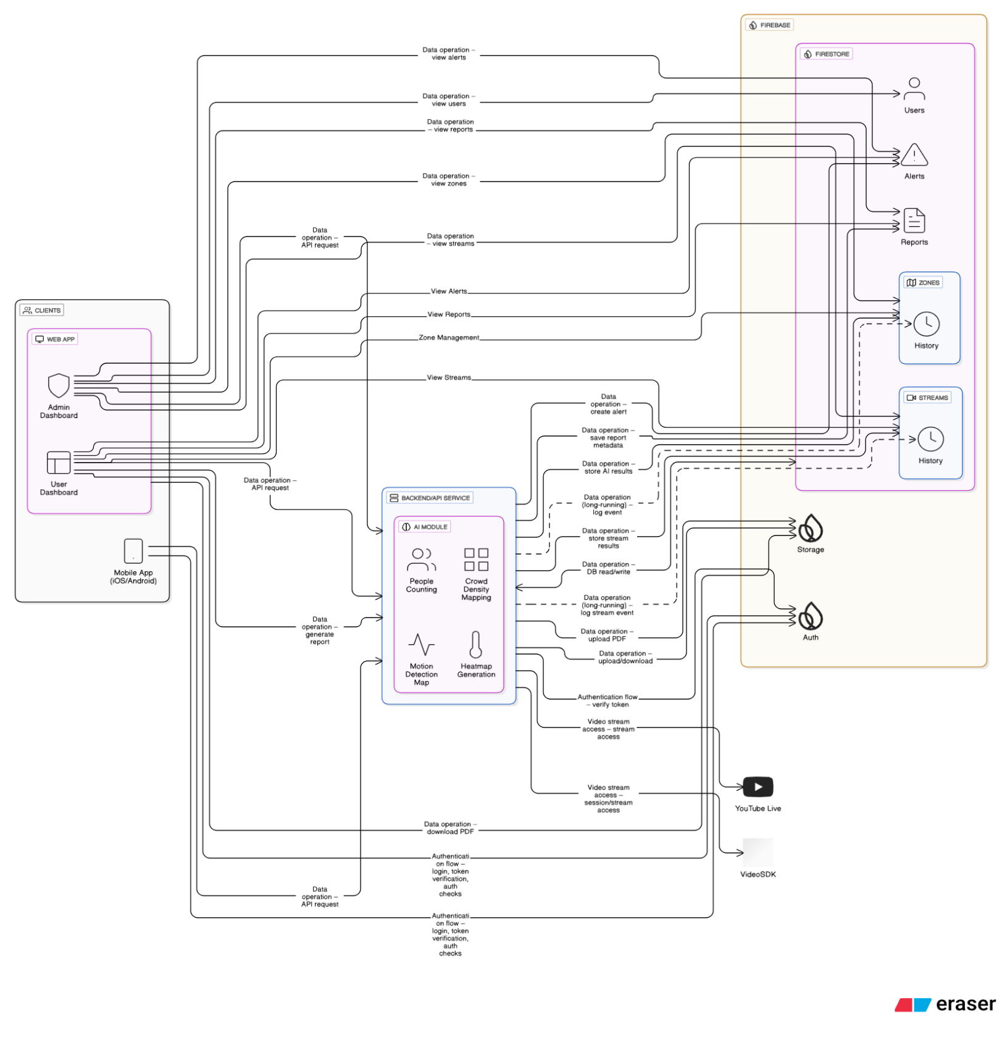

Figure 3.1 illustrates the overall system architecture, showing how its main modules interact
3.1.1 The architecture is designed (main modules):
- Client Applications
The system provides two main client applications targeting different user roles:
- Web Application: Built using React and TypeScript, the web application serves as an administrative dashboard. Administrators can register users, manage zones, monitor live streams, view real-time alerts, access detailed reports, and oversee system operations through an intuitive interface.
- Mobile Application: Developed with Flutter for cross-platform mobile application, the mobile app allows end-users to register, define and manage monitoring zones, start or view live video streams, receive alerts, and generate or download reports.
Both applications communicate securely with the backend through REST API requests and use Firebase Authentication to manage user sign-up, login, and access control.
- Backend Service and AI Module
The backend is developed in Python using the Flask framework. It exposes a REST API that handles all business logic, including processing user requests, managing video sessions, orchestrating AI tasks, and generating reports.At the core of the backend is the AI Processing Module, which implements advanced computer vision tasks such as:
- People Counting — detecting and counting individuals in each video frame.
- Crowd Density Mapping — estimating crowd distribution over defined zones.
- Motion Detection — identifying movement patterns in monitored areas.
- Heatmap Generation — visualizing crowd density and movement intensity over time.
The AI module uses a custom CLIP-EBC model built with PyTorch. Incoming video streams are handled via VideoSDK or linked from external YouTube Live feeds. Each video frame is processed by the AI module in near real time, with results returned to the backend for storage and alerting.
- Cloud Infrastructure
The system uses Firebase as its cloud backend, providing the following services:
- Firestore: A scalable NoSQL database that stores all structured data, including user profiles, zone configurations, live stream metadata, historical logs, alerts, and generated reports.
- Firebase Authentication: Manages secure user registration and session management for both web and mobile applications.
- Firebase Storage: Stores large files such as generated PDF reports, allowing users to download or share them.

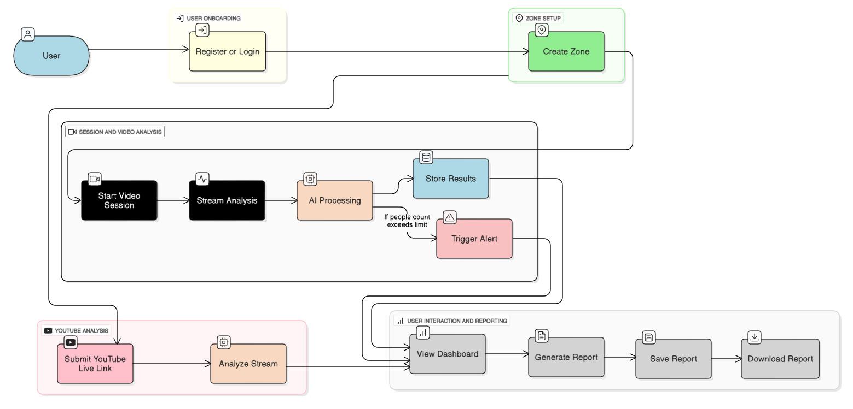

Figure 3.1: High-level process flow showing user onboarding, zone drsetup, video session handling, AI processing, and reporting.
3.1.2 User FlowChart
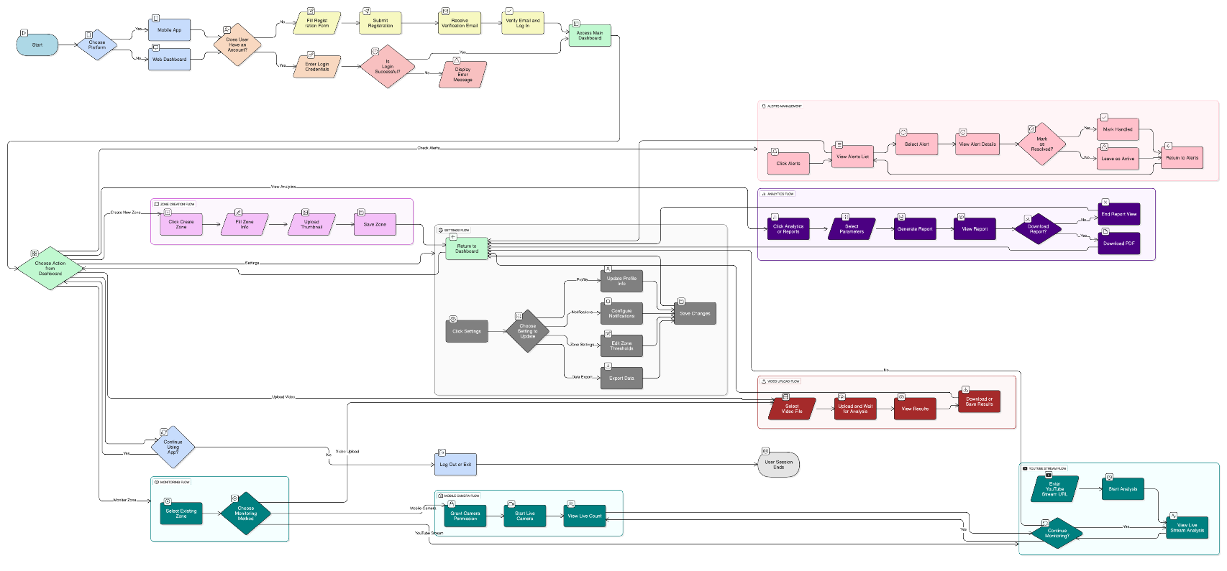

Data Flow and Workflow
The architecture facilitates a seamless workflow for crowd monitoring.

Figure 3.3: Flowchart of User Workflow and System Processes

1. Initial User Entry and Platform Selection
The system begins with users accessing the platform through two primary entry points:
- Mobile App: Native Flutter application for end-users
- Web Dashboard: React-based administrative interface
Users must authenticate through Firebase Authentication, supporting both new user registration and existing user login flows.
2. Core User Journey Workflows
Authentication and Onboarding Flow
- Users enter name, email, and verification details
- Firebase Authentication handles user credentials and email verification
- Upon successful authentication, users access the main dashboard with personalized navigation
3. Zone Management Workflow
- Zone Setup: Users create monitoring zones by specifying:
  - Zone name and description
  - Maximum occupancy thresholds
  - Geographic boundaries
  - Associated camera sources
- Zone Configuration: Users upload reference images and configure monitoring parameters
4. Multi-Modal Video Input Processing
The system supports two distinct video input methods:
Live Mobile Camera Stream
- Users initiate VideoSDK sessions directly from mobile devices
- Real-time camera feed processing with immediate AI analysis
YouTube Live Stream Integration
- Users provide YouTube Live stream URLs

- Analytics and Reporting Workflow
Data Aggregation
- Historical data compilation from multiple monitoring sessions
- Statistical analysis of crowd patterns and peak times
- Trend identification and pattern recognition

Report Generation
- PDF Generation: Automated report creation with charts and statistics
- Export Options: Multiple format support for data export
- Firebase Storage: Report storage and download link generation

3.2 Tools and Technologies Used
3.2.1 Frontend Development
Web Application :
- React: Modern JavaScript library for building the administrative web dashboard interface, chosen for its component-based architecture and extensive ecosystem
- TypeScript: Provides static type checking and enhanced development experience, reducing runtime errors and improving code maintainability
- Vite: Modern build tool selected for fast development server and optimized production builds with hot module replacement
- Tailwind CSS: Utility-first CSS framework enabling rapid UI development with consistent design systems and responsive layouts
Mobile Application:
- Flutter: Google's cross-platform framework chosen for native performance across iOS and Android with single codebase
- Dart Programming Language: Modern, object-oriented language optimized for client development
- Flutter BLoC: Business Logic Component pattern for predictable state management and separation of concerns
- Go Router :Declarative routing solution for Flutter applications
- VideoSDK: Real-time video communication SDK enabling live camera streaming and video conferencing capabilities
3.2.2 Backend Development
AI Processing Engine:
- Python: Programming language chosen for its extensive machine learning ecosystem and library support
- PyTorch: Deep learning framework selected for its dynamic computation graphs and research-friendly environment
- CLIP-EBC Model: Custom crowd counting model based on CLIP (Contrastive Language-Image Pre-training) architecture, enhanced with Enhanced Blockwise Classification for accurate people counting
- FastAPI: Modern, fast web framework for building APIs with automatic interactive documentation and type validation
- OpenCV: Computer vision library for image processing, video capture, and real-time video analysis
- NumPy: Fundamental library for numerical computing and array operations
- Scikit-Image: Image processing library for advanced computer vision algorithms including SSIM (Structural Similarity Index) for motion detection

Video Processing & Streaming
- yt-dlp: YouTube video downloader and stream extractor for processing YouTube Live streams
- VideoSDK API: Real-time video communication platform for handling live camera feeds and video sessions
Cloud Infrastructure & Database
- Firebase Ecosystem
      - Firebase Authentication: Secure user authentication service supporting multiple sign-in methods
      - Cloud Firestore: NoSQL document database for real-time data synchronization across all platforms
      - Firebase Storage: Cloud storage solution for storing generated reports, images, and media files
3.3 Software Functionalities
The AI-powered crowd monitoring system provides a comprehensive suite of functionalities designed to address the critical challenges of real-time crowd management and safety monitoring. Each feature is strategically developed to contribute to effective crowd control, early warning systems, and data-driven decision making.
3.3.1 User Authentication and Access Management
Secure Authentication System
The platform implements Firebase Authentication to provide secure user registration and login capabilities across both mobile and web applications. This functionality ensures that only authorized personnel can access crowd monitoring systems and sensitive data.
Problem-Solving Contribution: Protects sensitive crowd data and ensures accountability by maintaining user access logs. This is crucial for security-sensitive environments where unauthorized access could compromise public safety operations.
Multi-Platform Access Control
Users can seamlessly access the system through dedicated mobile applications (Flutter-based) and web dashboards (React-based) with synchronized authentication states.
Problem-Solving Contribution: Enables flexibility in monitoring operations, allowing security personnel to use mobile devices for field monitoring while administrators can access comprehensive analytics through web dashboards.
3.3.2 Zone Creation and Management
Intelligent Zone Configuration
Users can create and configure multiple monitoring zones with customizable parameters including zone names, geographical boundaries, maximum occupancy thresholds, and reference images for each area.
Problem-Solving Contribution: Addresses the need for location-specific crowd monitoring by allowing operators to define precise areas of interest with appropriate capacity limits, enabling targeted surveillance of high-risk areas such as emergency exits, stage fronts, or narrow corridors.
Dynamic Threshold Management
The system allows real-time modification of crowd density thresholds for each zone based on changing event conditions or safety requirements.
Problem-Solving Contribution: Provides adaptive crowd management capabilities, essential for events where acceptable crowd densities may vary throughout different phases (e.g., entry, performance, exit phases).
3.3.3 Multi-Modal Video Input Processing
Live Mobile Camera Integration
The mobile application leverages VideoSDK technology to enable real-time camera streaming directly from mobile devices, allowing field personnel to instantly monitor crowd conditions.
Problem-Solving Contribution: Eliminates the dependency on fixed camera infrastructure, enabling rapid deployment in temporary events or emergency situations where permanent surveillance systems are unavailable.
YouTube Live Stream Analysis
The system can process YouTube Live streams using advanced video extraction techniques, enabling monitoring of publicly broadcasted events or integration with existing streaming infrastructure.
Problem-Solving Contribution: Extends monitoring capabilities to remotely broadcasted events and enables crowd analysis of large-scale public gatherings without requiring physical presence or additional hardware deployment.
3.3.4 Advanced AI-Powered Analysis Engine
The system employs a state-of-the-art CLIP-Enhanced Blockwise Classification model that achieves superior accuracy in people counting compared to traditional methods, with Mean Absolute Error (MAE) of 61.2 on NWPU dataset.
Problem-Solving Contribution: Provides highly accurate real-time people counting essential for making critical safety decisions. The enhanced accuracy reduces false alarms while ensuring genuine overcrowding situations are detected promptly.
3.3.5 Real-Time Monitoring and Alerting
Continuous Monitoring Dashboard
Both mobile and web applications provide real-time dashboards displaying live video feeds, current crowd counts, motion scores, and historical trends with updates every 5 seconds.
Problem-Solving Contribution: Ensures operators maintain situational awareness of crowd conditions across multiple zones simultaneously, preventing oversight of developing dangerous situations.
Intelligent Alert System
The system automatically generates alerts when crowd counts exceed predefined thresholds, capturing relevant frames and context data for immediate review.
Problem-Solving Contribution: Provides early warning system for potential overcrowding situations, enabling timely intervention before dangerous conditions develop. Automated alerts ensure that threshold violations are never missed, even during periods of operator distraction.
Push Notification Integration
Mobile applications receive instant push notifications for critical alerts, ensuring field personnel are immediately informed of developing situations.
Problem-Solving Contribution: Enables rapid response to emergency situations by ensuring key personnel are notified regardless of their current activity or location.
3.3.6 Analytics and Reporting Capabilities
Comprehensive Data Analytics
The system provides detailed analytics including historical crowd trends, peak occupancy times, average dwell times, and crowd flow patterns across different time periods.
Problem-Solving Contribution: Supports data-driven decision making for event planning, capacity management, and safety protocol development by identifying patterns and trends that inform future crowd management strategies.
Automated Report Generation
Users can generate detailed PDF reports containing statistical analysis, trend graphs, alert summaries, and visual documentation of crowd events.
Problem-Solving Contribution: Facilitates compliance reporting, incident documentation, and stakeholder communication by providing professional, comprehensive reports that can be used for regulatory compliance, insurance claims, or operational reviews.
Historical Data Management
The system maintains comprehensive historical records of all monitoring sessions, enabling long-term trend analysis and comparative studies.
Problem-Solving Contribution: Enables continuous improvement of crowd management strategies by analyzing the effectiveness of past interventions and identifying recurring patterns that require attention.

4. Methodology
4.1 Data Collection and Preprocessing
Datasets
The NWPU-Crowd dataset was utilized for our crowd counting model. This large-scale dataset contains 5,109 images collected from self-shooting and the Internet, capturing diverse crowd scenes in populous Chinese cities like Beijing, Shanghai, and Xi'an. It includes typical scenarios such as resorts, walking streets, campuses, malls, museums, and stations, with a total of over 2.1 million labeled head points. The dataset features varied conditions, including normal lighting, extreme brightness, low luminance, and negative samples with densely arranged objects, making it one of the most challenging datasets for crowd counting and localization.
Preprocessing Steps
For our crowd counting model, high-resolution images from the NWPU-Crowd dataset were resized to a 2048x6 scale while preserving the original aspect ratio. Density maps were generated using a Gaussian kernel with a fixed size of 15 and a standard deviation (σ) of 4. During training, data augmentation techniques were applied, including random cropping to a size of 576x768, horizontal flipping, transformation to grayscale, and gamma correction with a random value in the range [0, 1.2]. These steps enhanced the model's robustness to variations in the dataset.

4.2 Model Development
The proposed model, CLIP-EBC [19 ], builds upon the foundation of the CLIP (Contrastive Language-Image Pretraining) model and integrates it into a novel Enhanced Blockwise Classification (EBC) framework for crowd counting. Unlike traditional regression-based approaches, this framework treats counting as a classification problem over discretized bins of count values, allowing more robust learning especially under long-tailed distributions of crowd sizes.

Core Design:
- Integer-Valued Binning: Unlike previous classification-based methods that rely on Gaussian-smoothed, continuous bins, EBC uses discrete, integer-based count bins, avoiding ambiguities and ensuring prompt compatibility with CLIP’s language encoder.
- Noise Reduction: To handle label noise in extremely dense regions, blocks with counts exceeding a predefined threshold are grouped into a single ‘large count’ bin, mitigating class imbalance.
- Combined Loss Function: Training minimizes a novel Distance-Aware Cross-Entropy (DACE) loss, balancing classification consistency and count accuracy. This combines standard cross-entropy with a count regression term, weighted by a factor λ\lambdaλ.
The ViT-B/16 encoder extracts spatial feature maps, which are upsampled and projected into the CLIP embedding space. In parallel, discrete text prompts (e.g., “There are 3 people”) are embedded using CLIP’s frozen text encoder. The cosine similarity between image and text embeddings produces a probability map over bins, which is then used to compute the final density map.
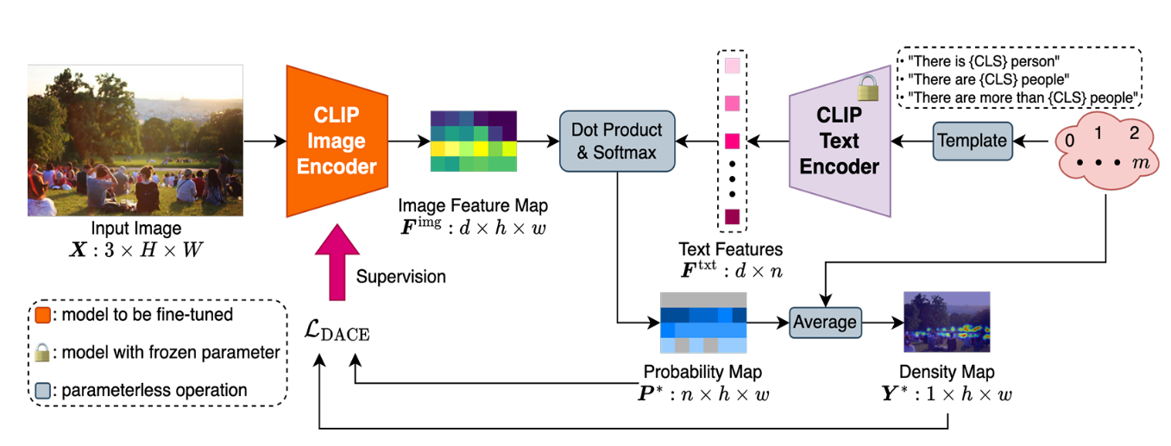
Figure 4.1: Architecture of CLIP-EBC
CLIP-EBC Architecture:
Image Encoder: The CLIP image encoder is modified by removing the pooling and projection layers and adding a 1×1 convolution layer to preserve local information.
Text Encoder: Frozen CLIP text encoder is used to embed bin-specific natural language prompts like “There are 3 people” or “More than 5 people”.
Similarity Computation: Cosine similarity between local image features and text embeddings is computed and normalized using SoftMax to yield the final probability map.
Training process:
Input Size:
- For the ViT backbone, the input images are resized to 256 by 256.
Block Size:
- Fixed at r = 8 for fine spatial resolution
- The default block size is set to 8 by 8 pixels.
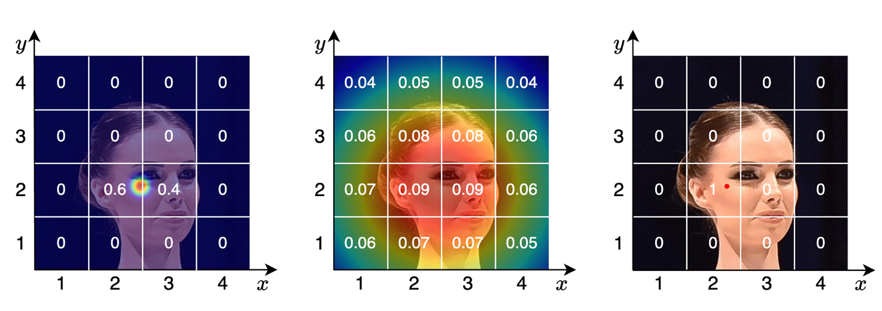

Maximum Recognizable Count per Block:
- This value is determined based on the block size and a fixed minimum recognizable person size, which is 4 by 4 pixels.
- For a block size of 8, the maximum count allowed per block results in five discrete bins.
Text Prompts:
- For each bin, a corresponding text prompt is generated (e.g., “There is 1 person” or “There are between 2 and 3 people”), with correct grammatical formatting.
4.3 Implementation
The implementation is developed in PyTorch, leveraging OpenAI’s released CLIP weights. Visual prompt tuning is applied by prepending learnable tokens to each ViT layer instead of fine-tuning the entire backbone, optimizing compute efficiency.
Key components:
- Custom Binning Module: Handles dynamic bin partitioning and prompt construction.
- Density Map Generator: Computes the expected local count per block by averaging bin midpoints weighted by classification probabilities.
- Visualization Pipeline: Generates qualitative comparisons between predicted and ground-truth density maps.
5. Results and Discussion
5.1 Model Performance
- The proposed CLIP-EBC (ViT-B/16) model demonstrates competitive performance on the NWPU-Crowd benchmark.

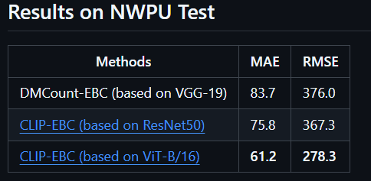

- Compared to other state-of-the-art methods, CLIP-EBC achieves the lowest MAE and RMSE, highlighting its ability to bridge vision-language representations and density map regression.
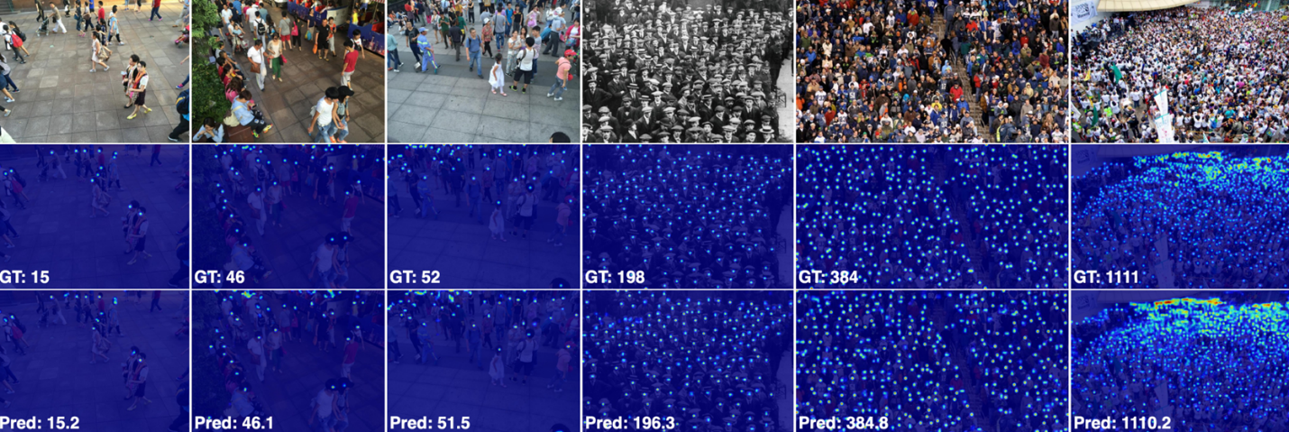

Figure 5.1: prediction and ground truth of the model prediction
Why Accuracy Is Not Used:
- Crowd counting is a regression problem, not a classification task.
- The goal is to predict a total count value, not assign class labels.
- Metrics like MAE and RMSE are preferred because they measure how close the predicted count is to the actual number of people.
5.2 Interpretation of Results
- Our model achieved a Mean Absolute Error (MAE) of 50.2 and Root Mean Square Error (RMSE) of 126.5. These results confirm the ability of CLIP-EBC to generalize across diverse crowd densities and layouts, despite using a vision-language model originally designed for recognition tasks. The incorporation of the Enhanced Blockwise Classification (EBC) framework allows the model to estimate crowd densities by comparing visual features to text-based count descriptions, rather than performing direct regression. This approach leverages the semantic power of CLIP and enables more robust interpretation of localized crowd distributions
- Compared to traditional regression-based models such as CSRNet and DMCount, our approach offers a new direction by reframing crowd counting as a classification problem with text-guided supervision. Although the ResNet50-based CLIP-EBC variant outperforms the ViT-B/16 version in terms of raw MAE and RMSE, our ViT-based model still performs competitively and demonstrates the flexibility of the architecture. It is also worth noting that models trained under the EBC framework consistently outperform their original versions, further validating the strength of our discretization, label correction, and loss design strategies.
- Higher RMSE compared to the ResNet-based CLIP-EBC indicates that ViT may be more sensitive to dense scenes or requires more training data to fully capture crowd distribution patterns.
- Training Efficiency: Vision transformers like ViT require more computational resources and longer training times compared to CNN-based backbones.
- No Fine-Tuning of Text Encoder: The CLIP text encoder is kept frozen during training. While this preserves generalization, it may limit performance gains specific to crowd counting tasks.
6. Illustrative Examples
Phase 1: Initial Setup and Registration
Step 1: Website Discovery and Account Creation
Detailed Steps:
1.1 User visits ru2ya.com
1.2 Views the landing page with AI crowd analysis demo
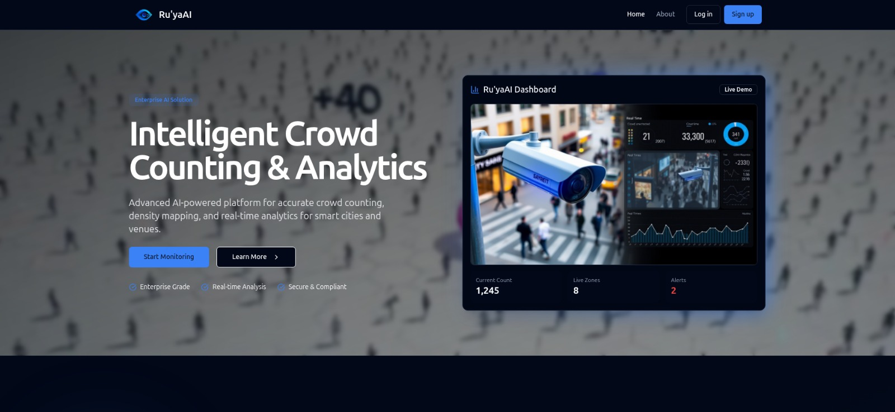
Figure 6.1: Landing Page of Ru'yaAI Website
1.3 Clicks "Start Monitoring" or "Sign Up" button
1.4 Redirected to registration page
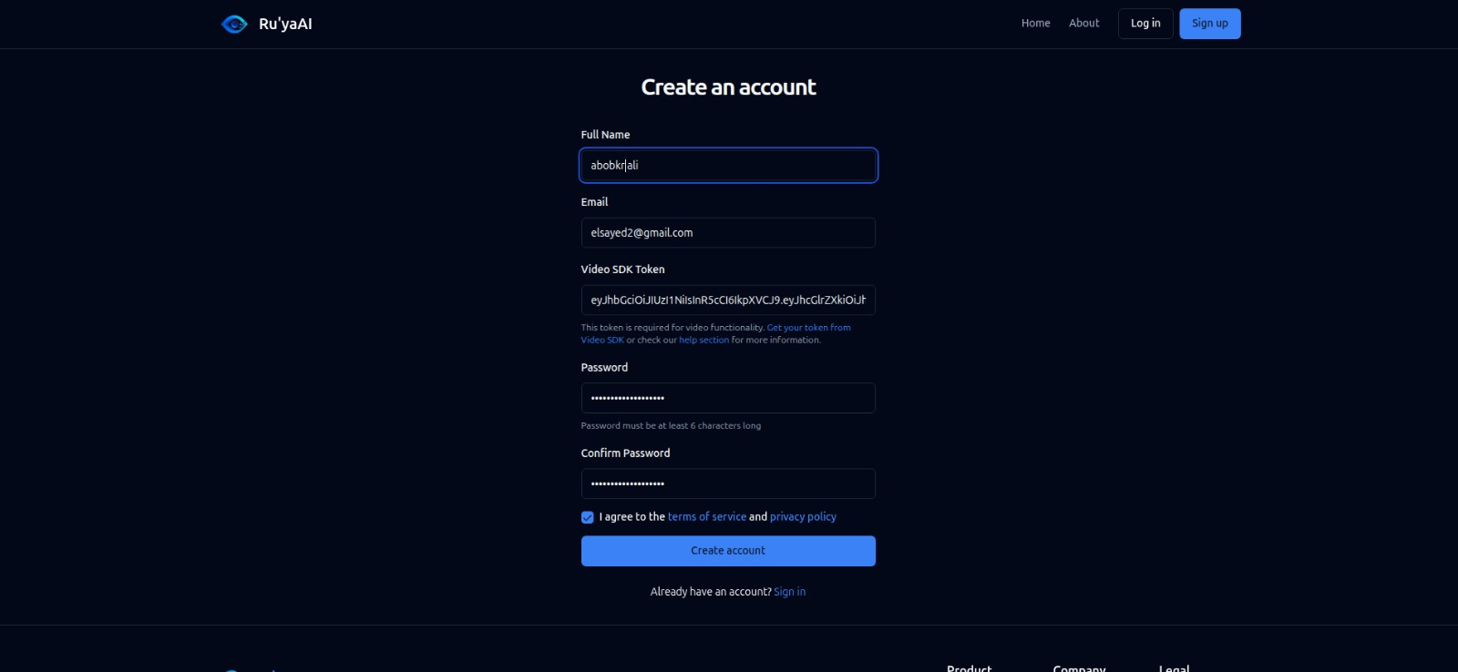
Figure 6.2 Ru'yaAI Website registration page
Step 2: VideoSDK Integration Setup
Pre-requisite: User needs VideoSDK token for real-time streaming
Detailed Steps:
2.1 User opens new tab and goes to VideoSDK website
2.2 Creates account on VideoSDK platform
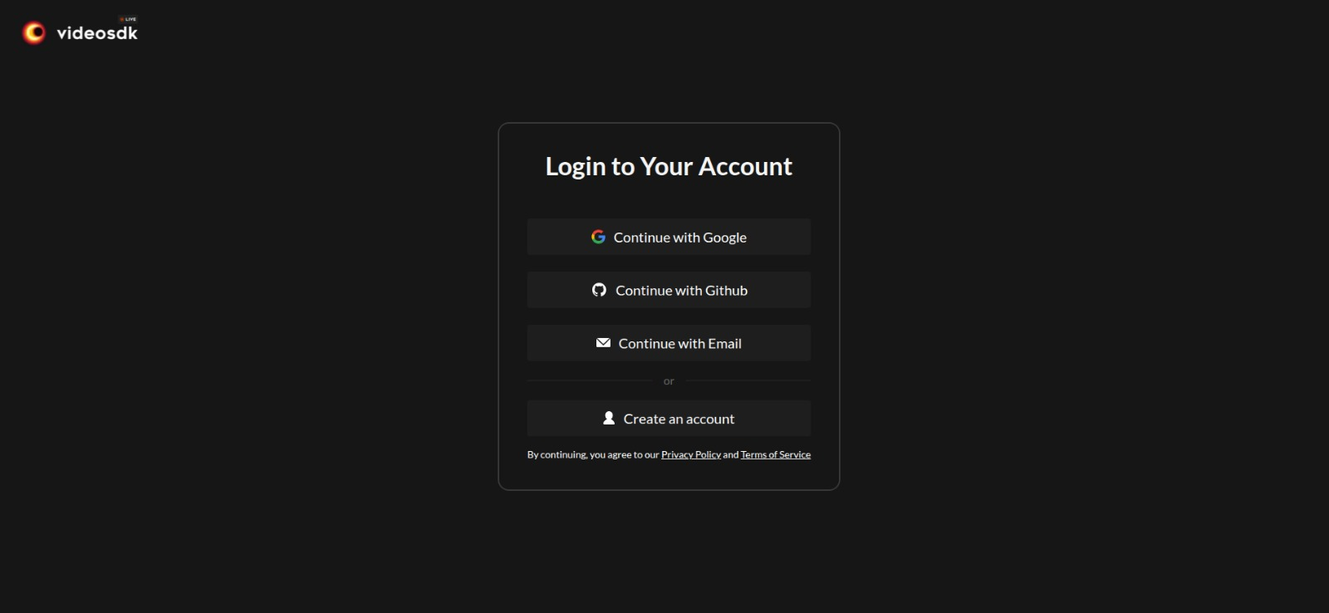
Figure 6.3: Creates account on VideoSDK
2.3 Navigates to API Keys section in VideoSDK dashboard
2.4 Clicks "Create New API Key"
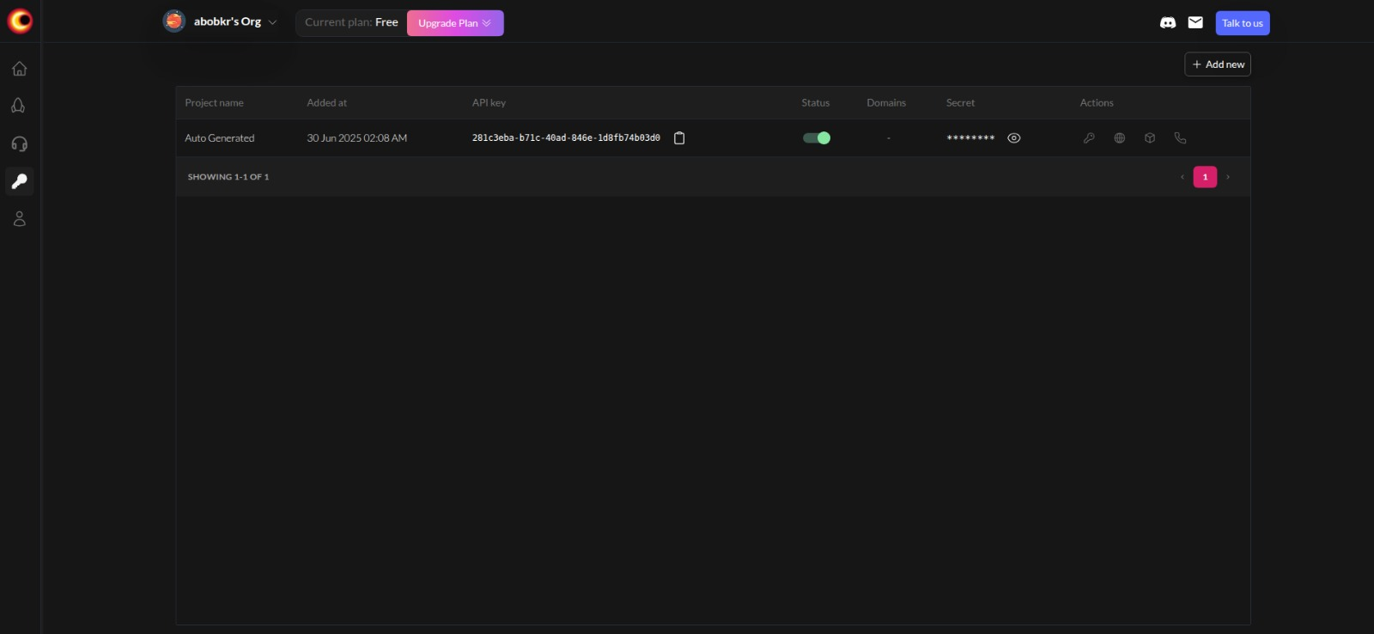
Figure 6.4: Creates Create New API Key on VideoSDK website
2.5 Generates API key for the project
Step 3: Token Generation Process
Detailed Steps:
3.1 In VideoSDK dashboard, finds the key icon/button next to API key
3.2 Clicks "Generate Token" button
3.3 Sets expiration date for the token (recommended: 6-12 months)
3.4 Copies the generated token to clipboard
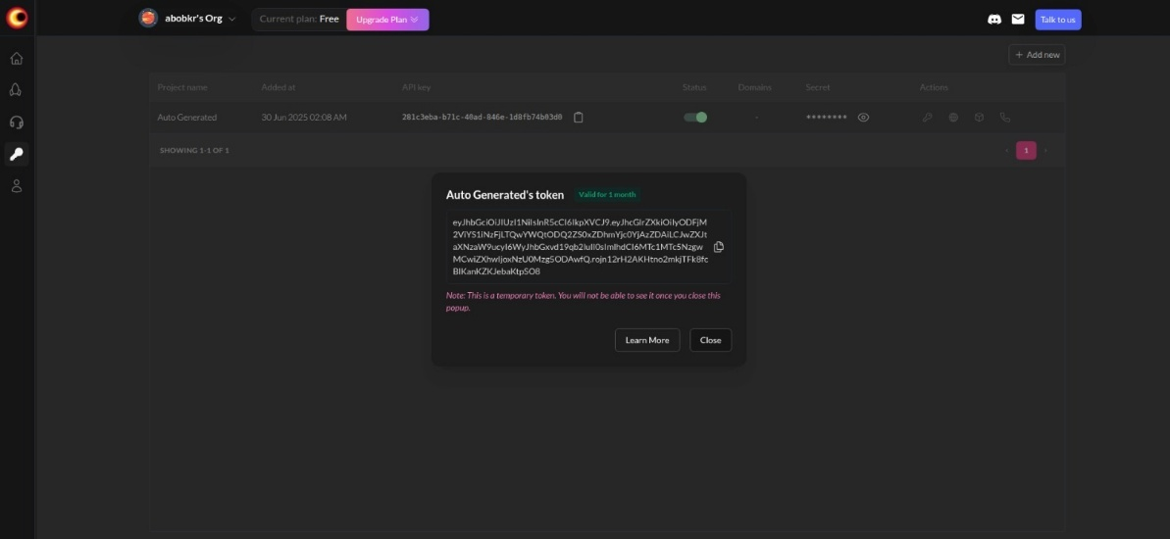
Figure 6.5: API key for the project

3.5 Returns to Ru'yaAI registration page
Step 4: Complete Account Registration
Form Fields: All required information for account setup
Registration Form Process:
4.1 Fills out registration form:
- Full Name: [User's full name]
- Email Address: [Valid email]
- VideoSDK Token: [Pastes copied token]
- Password: [Strong password]
- Confirm Password: [Same password]
4.2 Reads and accepts Terms and Conditions
4.3 Clicks "Create Account" button
4.4 Account is now active and ready to use
Figure 6.6: Complete Account Registration

Phase 2: First Login and Dashboard Overview
Step 5: Initial Dashboard Access
User Experience: Empty dashboard with no zone data
First Login Steps:
5.1 User logs in at
5.2 Redirected to main dashboard
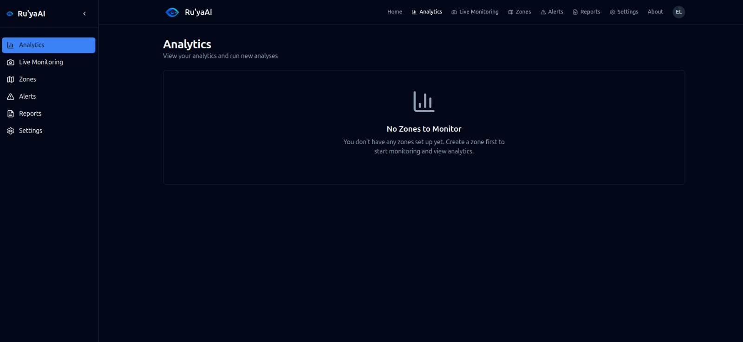
Figure 6.7: Initial State of analytics page
Step 6: Zones Page - Initial State
Current State: Empty zones page waiting for mobile setup
Navigation Path:
6.1 User clicks "Zones" in sidebar navigation
6.2 Zones page displays empty state:
- "No zones configured yet"
- "Use the mobile app to create your first monitoring zone"
- Instructions for mobile app setup
6.3 Provides links to download mobile apps (iOS/Android)
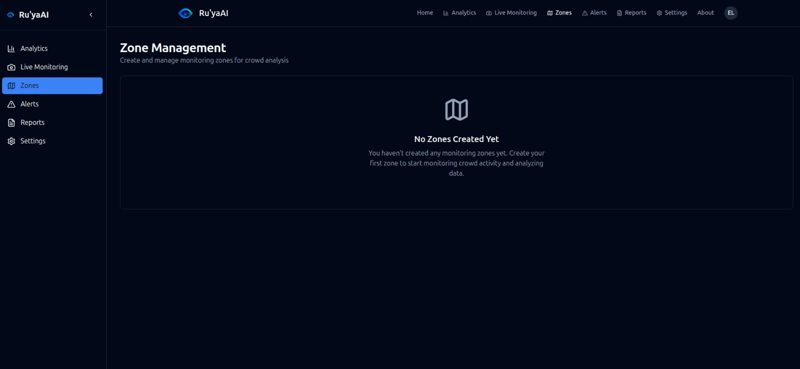
Figure 6.8: Initial State of zone pages
Phase 3: Mobile App Integration and Zone Creation
Step 7: Mobile App Installation and Login
Platform: Flutter-based mobile application "Ru'yaAI"
Mobile Setup Process:
7.1 Open "Ru'yaAI " mobile app
7.2 Logs in using same web account credentials:
- Email: [Same as web registration]
- Password: [Same as web registration]

Figure 6.9: Open mobile app and login

7.3 Mobile dashboard opens
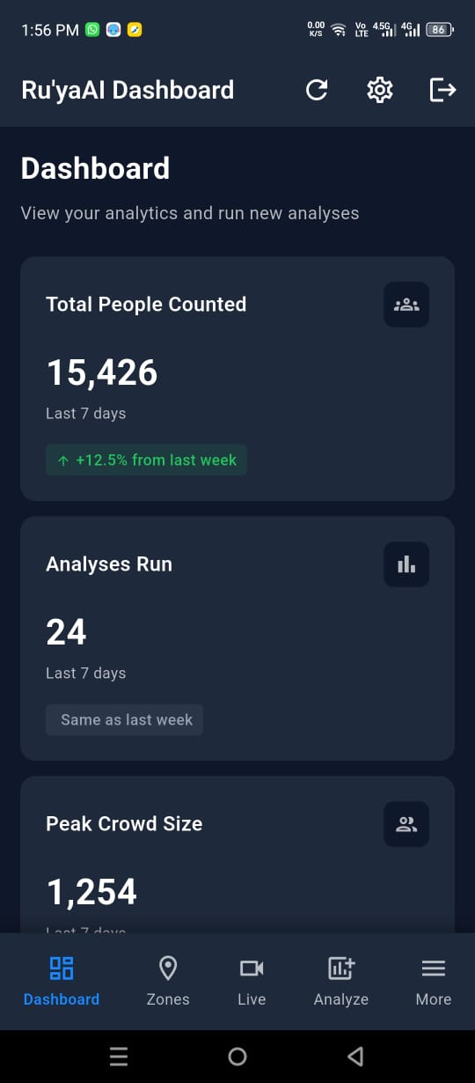
Figure 6.9: Dashboard on mobile app
7.4 App requests camera and location permissions

Step 8: Creatig First Zone on Mobile
Purpose: Set up monitoring area with mobile camera integration
Zone Creation Workflow:
8.1 In mobile app, navigates to "Zones" tab
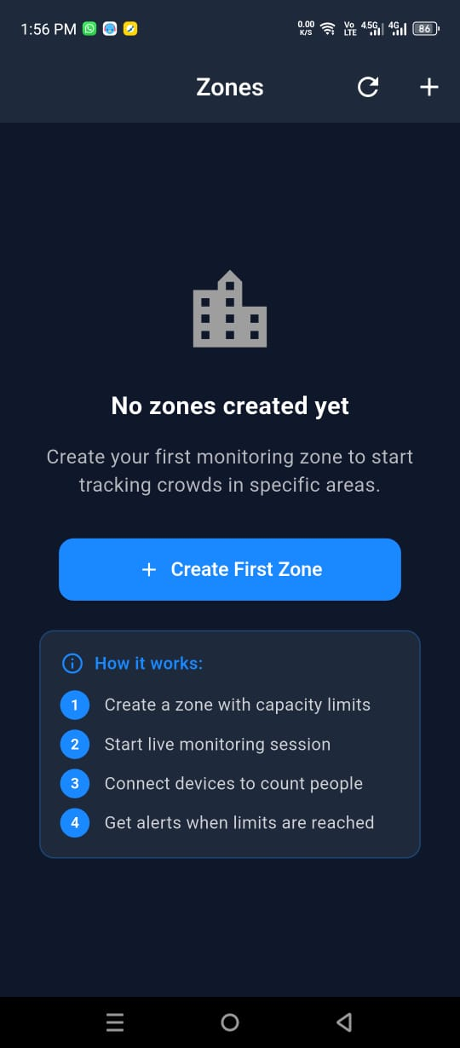

Figure 6.10: Create Zone in Mobile

8.2 Taps "Create New Zone" button (+)
8.3 Fills zone configuration form:
- Zone Name: "Main Entrance" (example)
- Location: "Building A Lobby"
- Description: "Primary entrance monitoring"
- Maximum Capacity: 150 people
- Alert Thresholds:
* Warning: 120 people (80%)
* Critical: 140 people (93%)
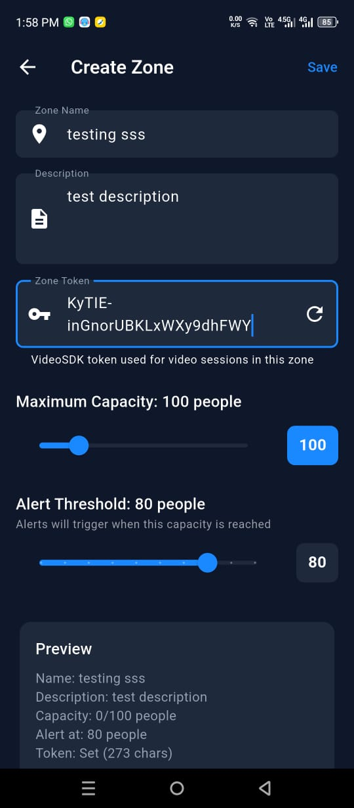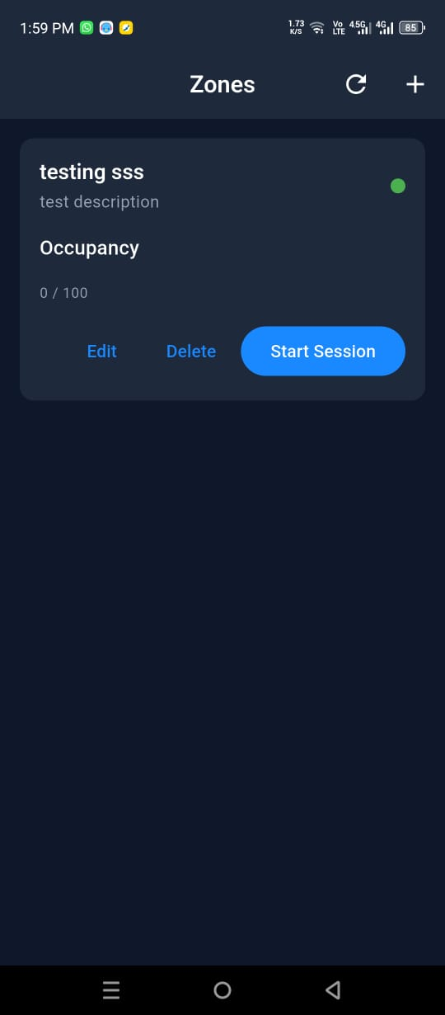
Figure 6.11: Zones configuration page

Step 9: Zone Activation and Streaming
Result: Zone becomes visible on web dashboard
Activation Process:
9.1 Created zone appears in mobile app
9.2 User refreshes web dashboard
9.3 Zone now appears in web zones page:
- Zone card shows basic information
- Status: "Created" (not yet streaming)
- "Connect" button available
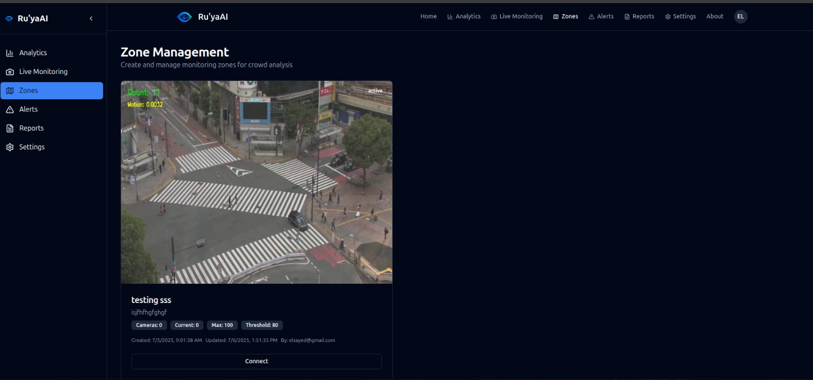
Figure 6.12: web page with zone created
9.4 Zone synchronization between mobile and web complete

Phase 4: Live Monitoring and Analytics
Step 10: Starting Live Stream Connection
Action: Connect mobile camera feed to web dashboardConnection Process:
Connection Process:
10.1 On web dashboard, clicks "Connect" button on zone card

10.2 Zone detail page opens with two main tabs:
- Tab 1: "Analytics" (AI analysis and insights)
- Tab 2: "Live Monitoring" (real-time stream)
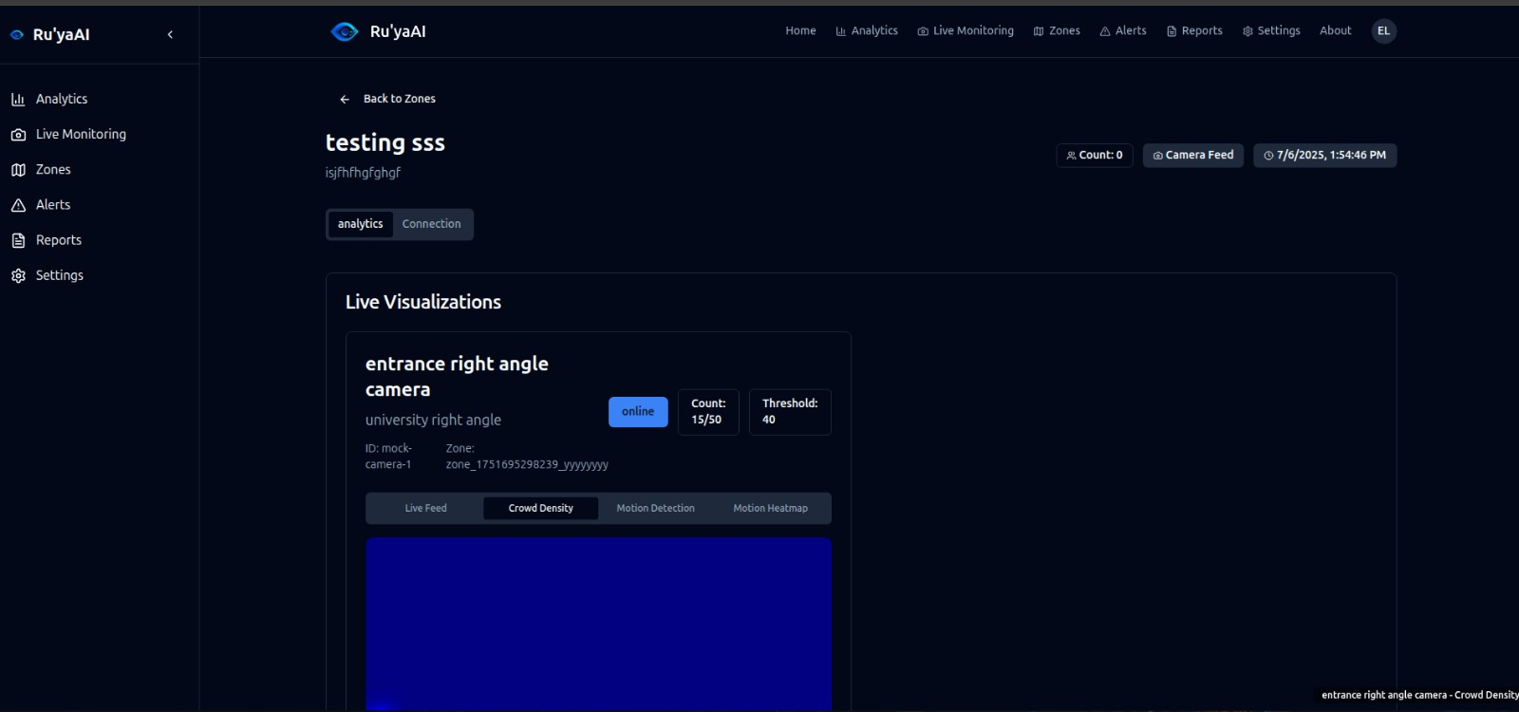
Figure 6.13: web page with Zone detail
10.3 In mobile app, user taps "Start Streaming" for the zone
10.4 Mobile camera activates and begins streaming
10.5 Web dashboard receives stream and displays:
- Live video feed from mobile camera
- AI overlay with person detection
- Real-time crowd count
- Density heatmap visualization
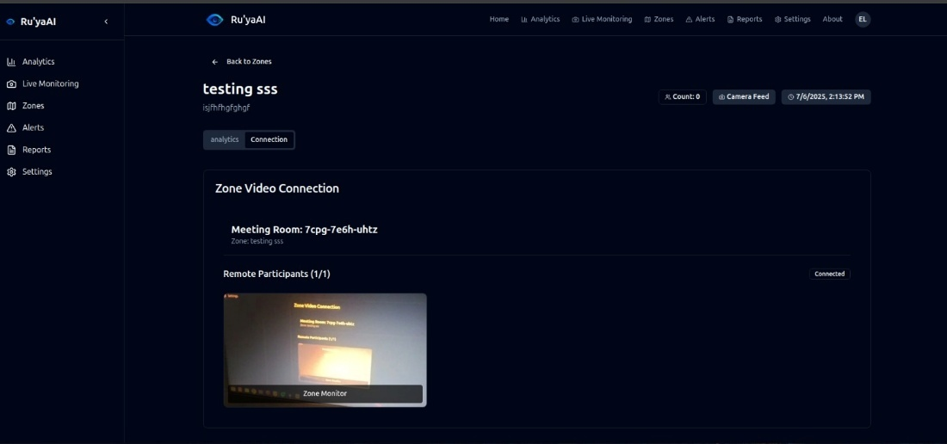
Step 11: Live Monitoring Interface
Purpose: Real-time crowd tracking and analysis
Live Monitoring Features:
11.1 Connection Page Display:
- Mobile camera stream in main viewport
- Current count: "23 people" (example)
- Density indicators with color coding
- Stream quality indicator: "HD - 30fps"
- Connection status: "Active"
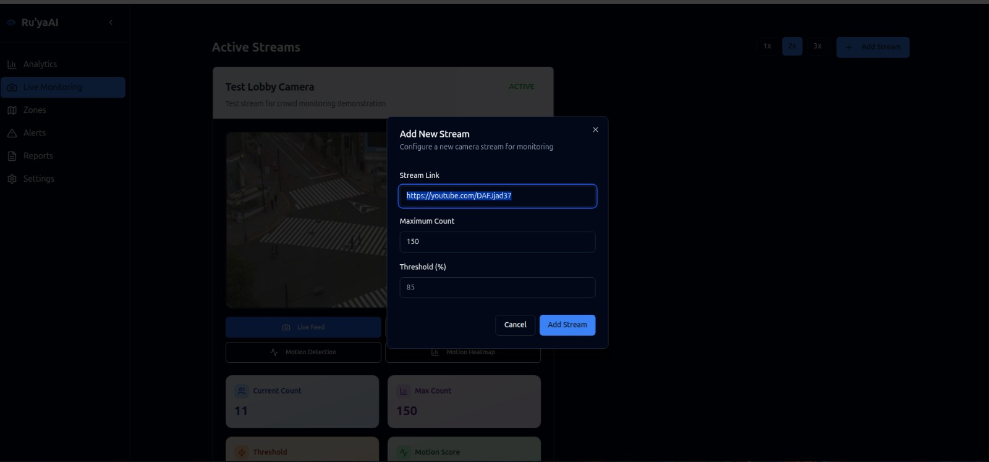
Figure 6.14: Live Monitoring page

11.2 User can add additional streams:
- "Add Stream" button in Live Monitoring page
- Support for multiple camera angles
- Grid view for multi-stream monitoring

11.3 Real-time AI Analysis:
- Person detection with bounding boxes
- Movement tracking with directional arrows
- Crowd density heatmap overlay
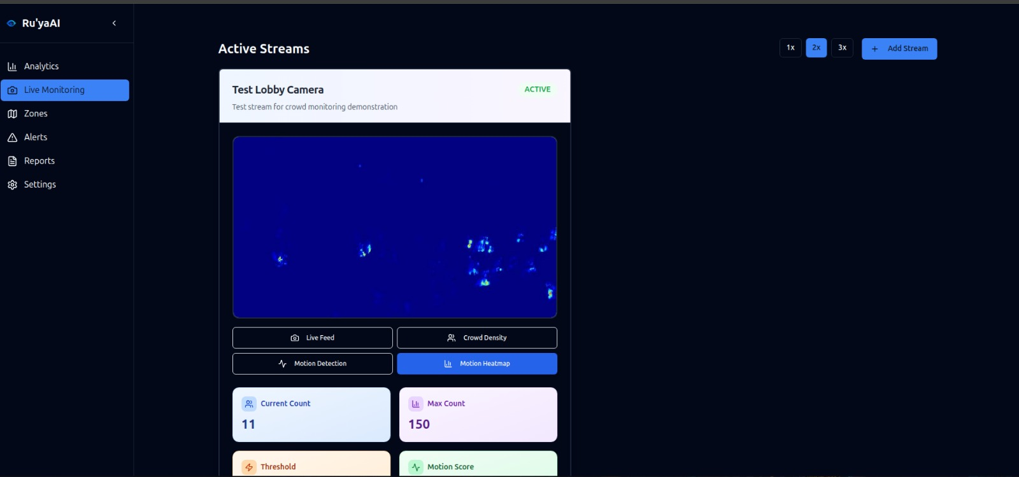
Figure 6.15: Live Monitoring with live density map and update

Step 12: Analytics Tab Features
Content: Zone statistics and historical data
Analytics Dashboard Sections:
12.1 Zone Statistics Panel:
- Current occupancy: 23 people
- Peak today: 67 people
- Average occupancy: 45%
- Hourly trend chart

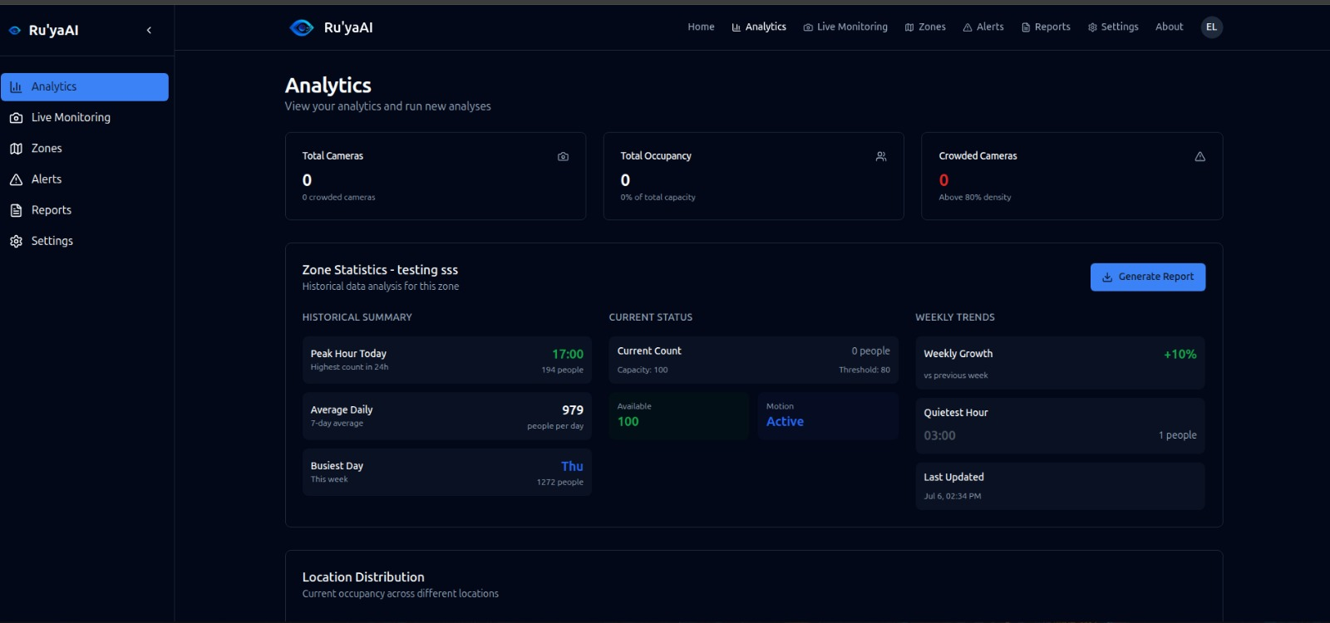
Figure 6.16: Analytic page

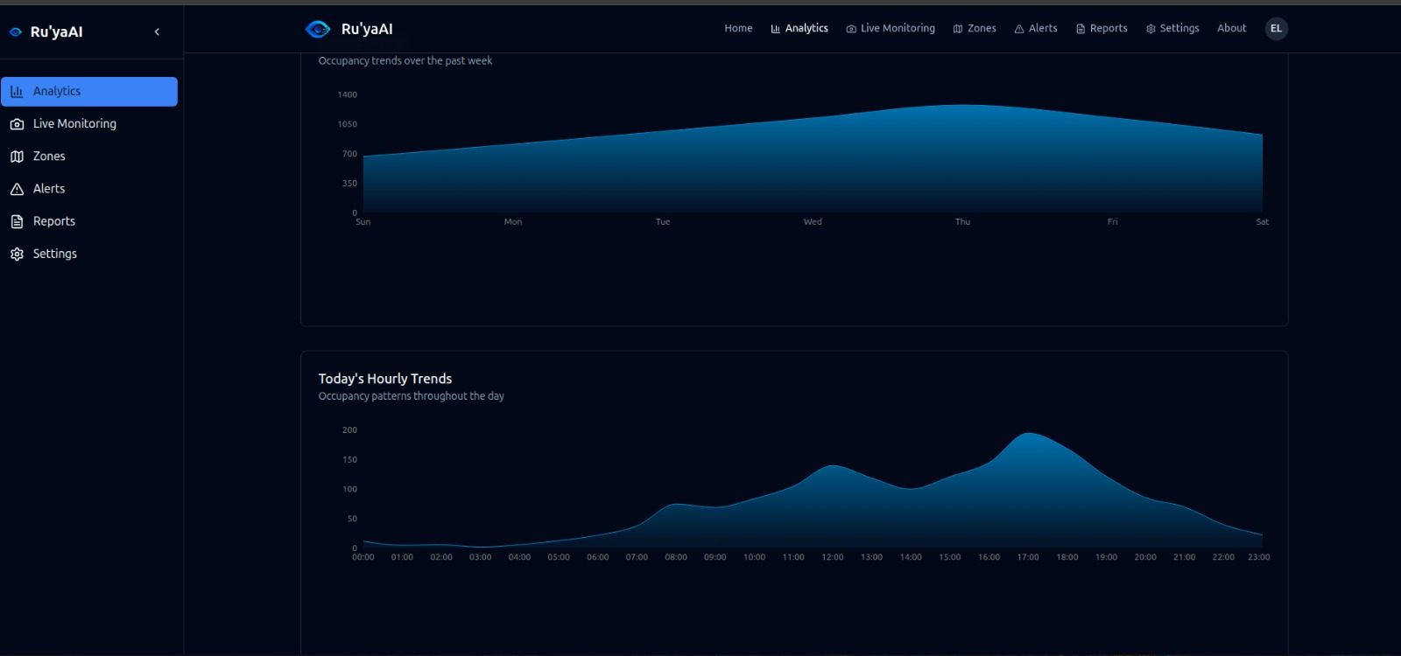
Figure 6.17: Dashboard

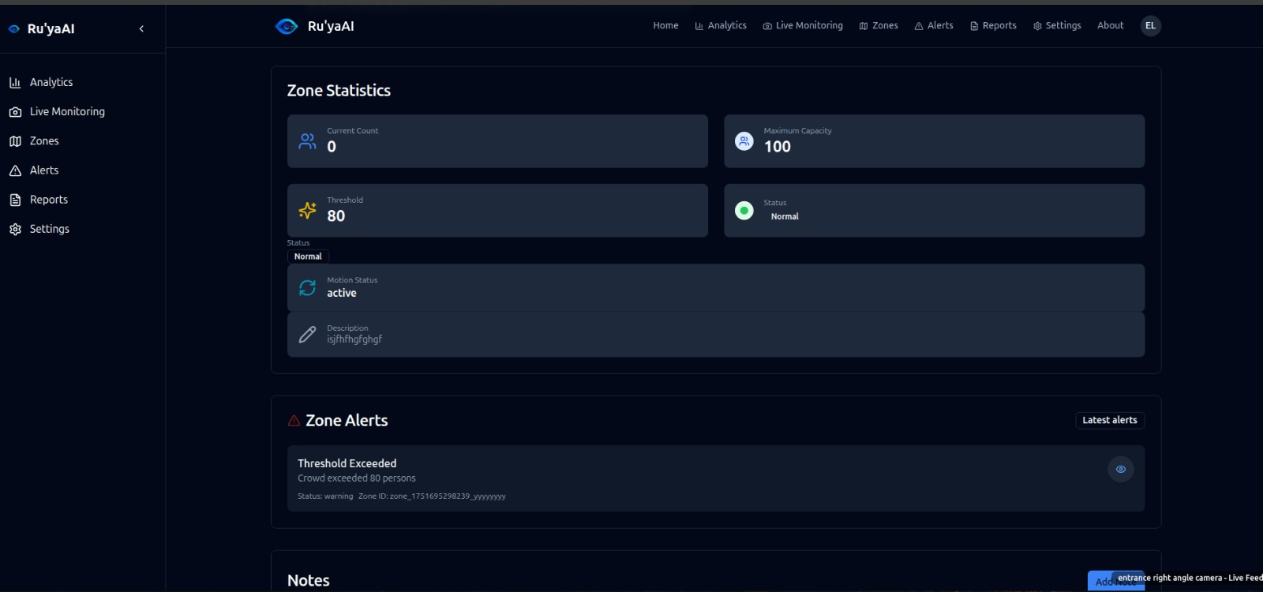
Figure 6.18: Analytic page when click on zone
12.2 Latest Alerts Section:
- Recent threshold breaches
- Camera offline notifications
- System status updates
- Alert timestamps and severity levels
12.3 Notes Management:
- Add custom notes: "Lunch rush period"
- Edit existing notes
- Delete notes with confirmation
- Notes appear in activity timeline
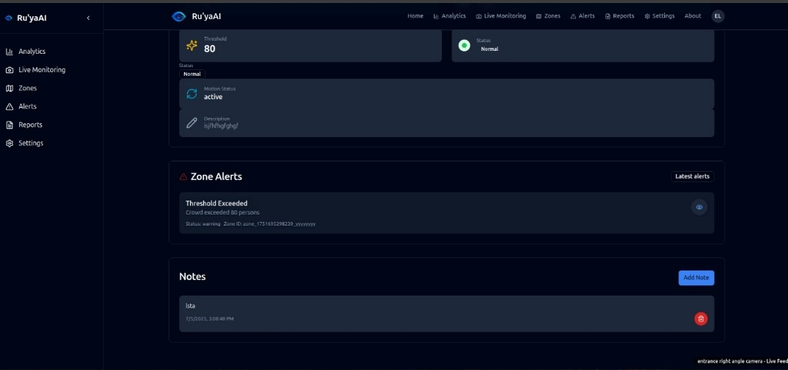
Figure 6.19: Note Page
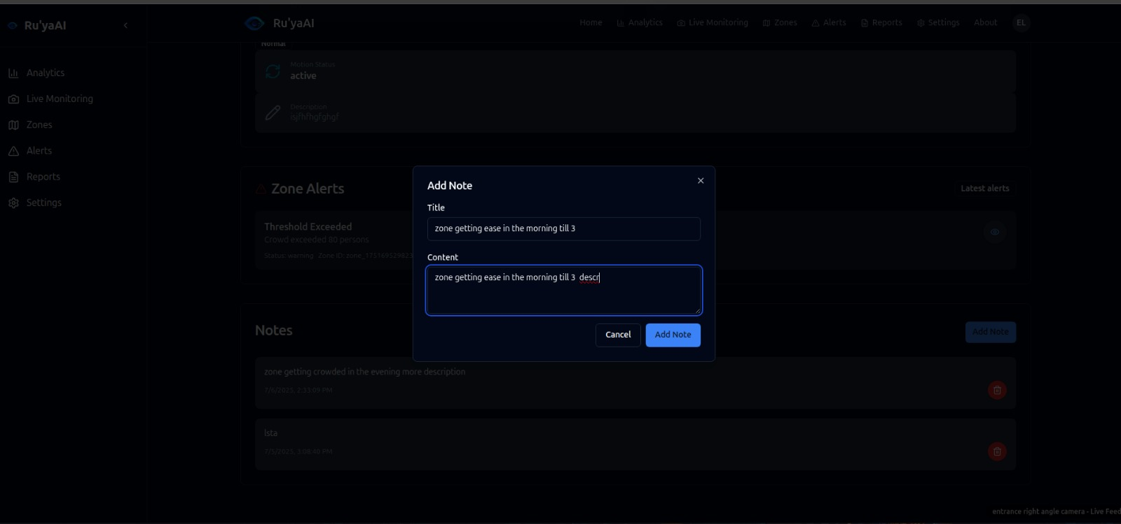
Figure 6.19: Add Note
12.4 Historical Analysis:
- Daily, weekly, monthly trends
- Occupancy patterns
- Peak hour identification
- Comparative analysis
Phase 5: Alert Management and Reporting
Step 13: Alerts Page and Management
Purpose: Monitor and respond to system notifications
Alerts Interface:
13.1 Navigate to Alerts page
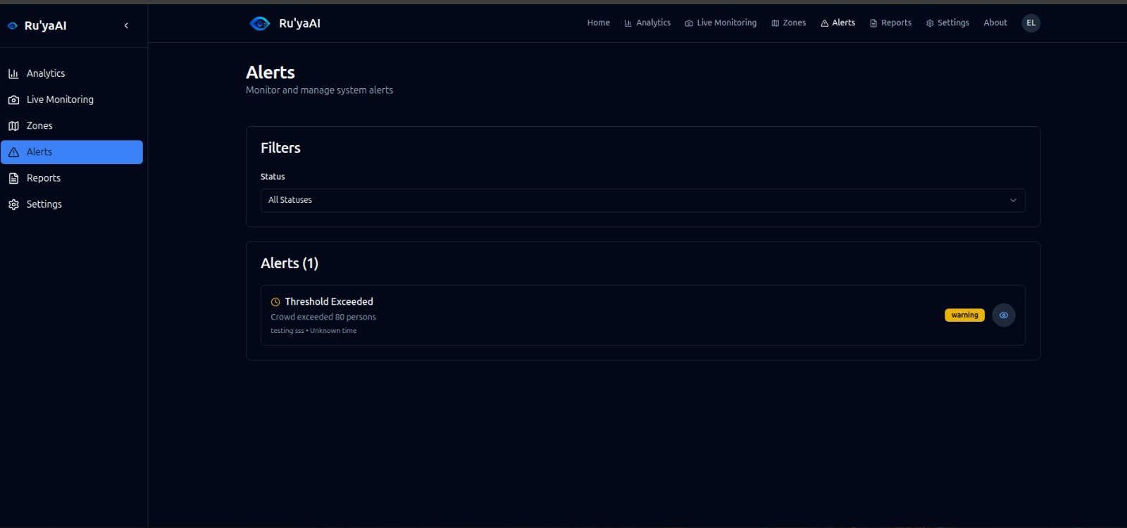
Figure 6.20: alerts page
13.2 Alerts list displays:
- Alert timestamp: "2024-01-15 14:23:15"
- Alert type: "Capacity Warning"
- Zone name: "Main Entrance"
- Severity level: High/Medium/Low
- Status: New/Acknowledged/Resolved
13.3 Alert Details (click eye icon):
- Full alert description and see capture of the scene when it happen
- Triggered threshold: "120 people exceeded"
- Current count at trigger: "127 people"
- Recommended actions
- Response history

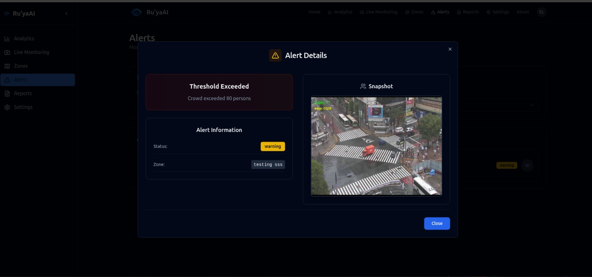
Figure 6.21: Eye icon to see what really happen actual capture of what happen to send this alert

Step 14: Advanced Analytics and History
Location: Analytics page with comprehensive data

Analytics Features:
14.1 Zone Analysis Section:
- Long-term occupancy trends
- Peak hour analysis
- Day-of-week patterns
- Monthly comparisons

14.2 Historical Data Views:
- Timeline scrubber for specific dates
- Occupancy heatmap calendar
- Trend line graphs
- Comparative zone analysis

14.3 Pattern Recognition:
- Automatic peak detection
- Unusual activity alerts
- Seasonal trend identification
- Predictive analytics (future feature)
Figure 6.22: Example of what analytics look like

Step 15: Report Generation and Management
Purpose: Create and manage analytical reports
Report Generation Process:
15.1 In Analytics page, click "Generate Report" button
15.2 Report configuration modal opens:
- Date range selection: "Last 7 days"
- Metrics to include: All selected
- Report format: PDF/Excel options
- Email recipients: Optional
15.3 Report generation process:
- "Generating report..." progress indicator
- Processing time: 15-30 seconds
- "Report saved successfully" confirmation
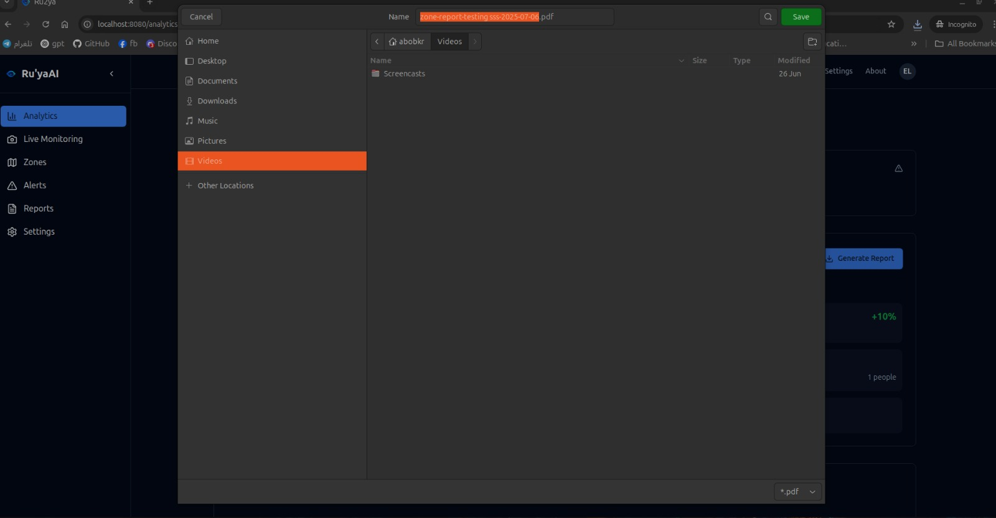
Figure 6.23: report page

15.4 Generated report includes:
- Executive summary
- Zone occupancy statistics
- Peak hour analysis
- Alert frequency data
- Visualizations and charts
- Recommendations section
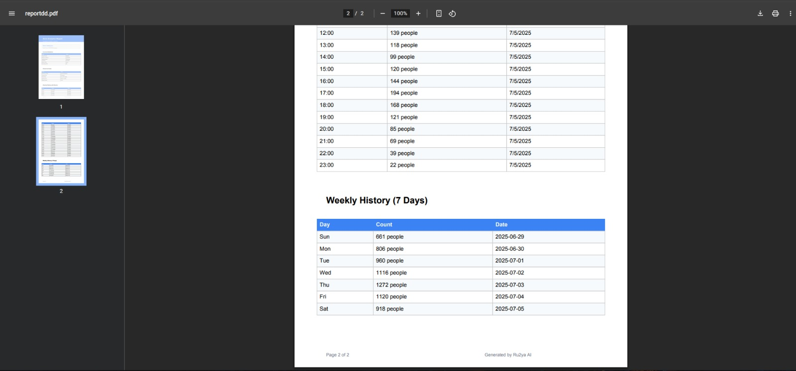
Figure 6.24: page from report generated
Step 16: Reports Page Management
Purpose: Access and manage all generated reports
Reports Management Interface:
16.1 Navigate to Reports page
16.2 Reports list displays:
- Report name: "Weekly Analysis - Main Entrance"
- Generation date: "2024-01-15"
- Date range covered: "Jan 8-14, 2024"
- File size: "2.3 MB"
- Status: "Ready"

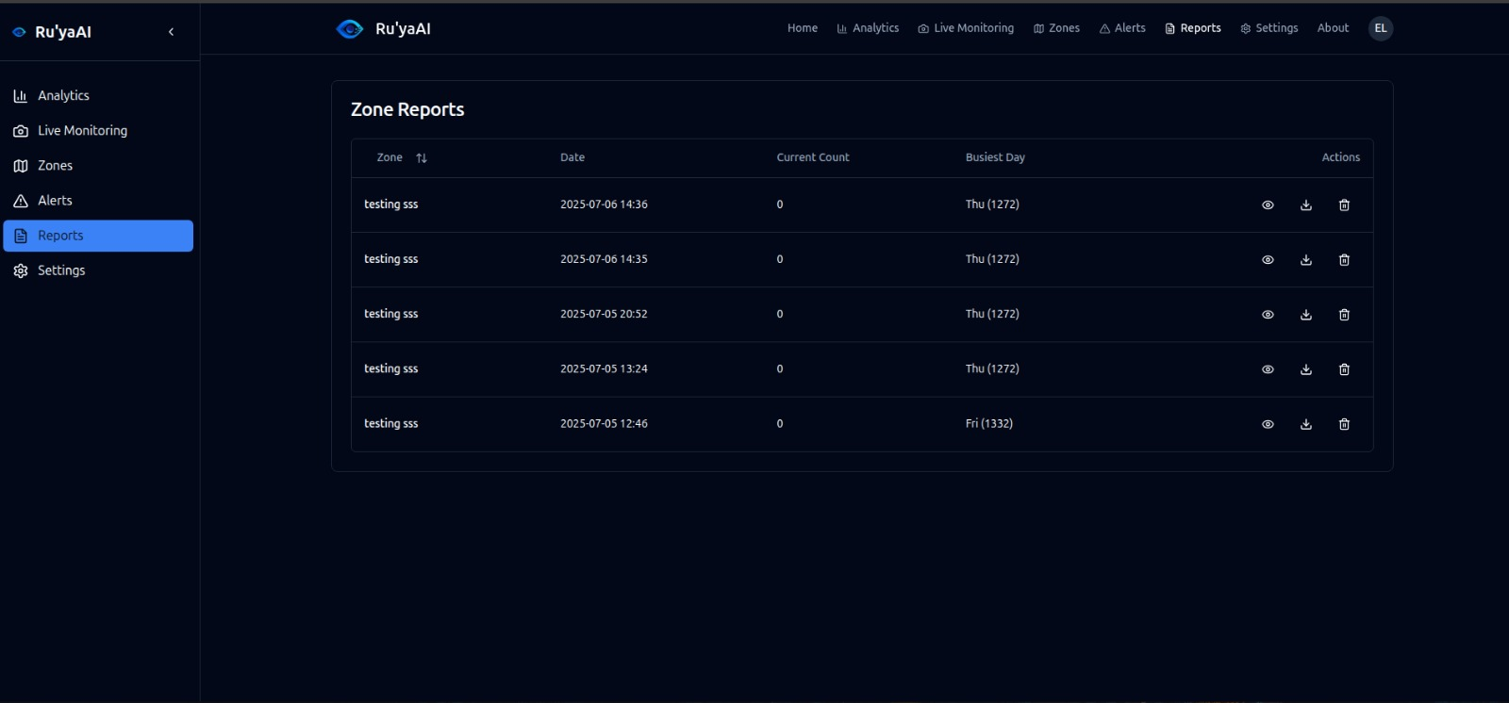
Figure 6.25: All report generated
16.3 Report Actions:
- Eye icon: View report details
- Download icon: Download PDF/Excel
- Delete icon: Remove report (with confirmation)

16.4 Report Details View (eye icon):
- Report preview with key metrics
- Summary statistics
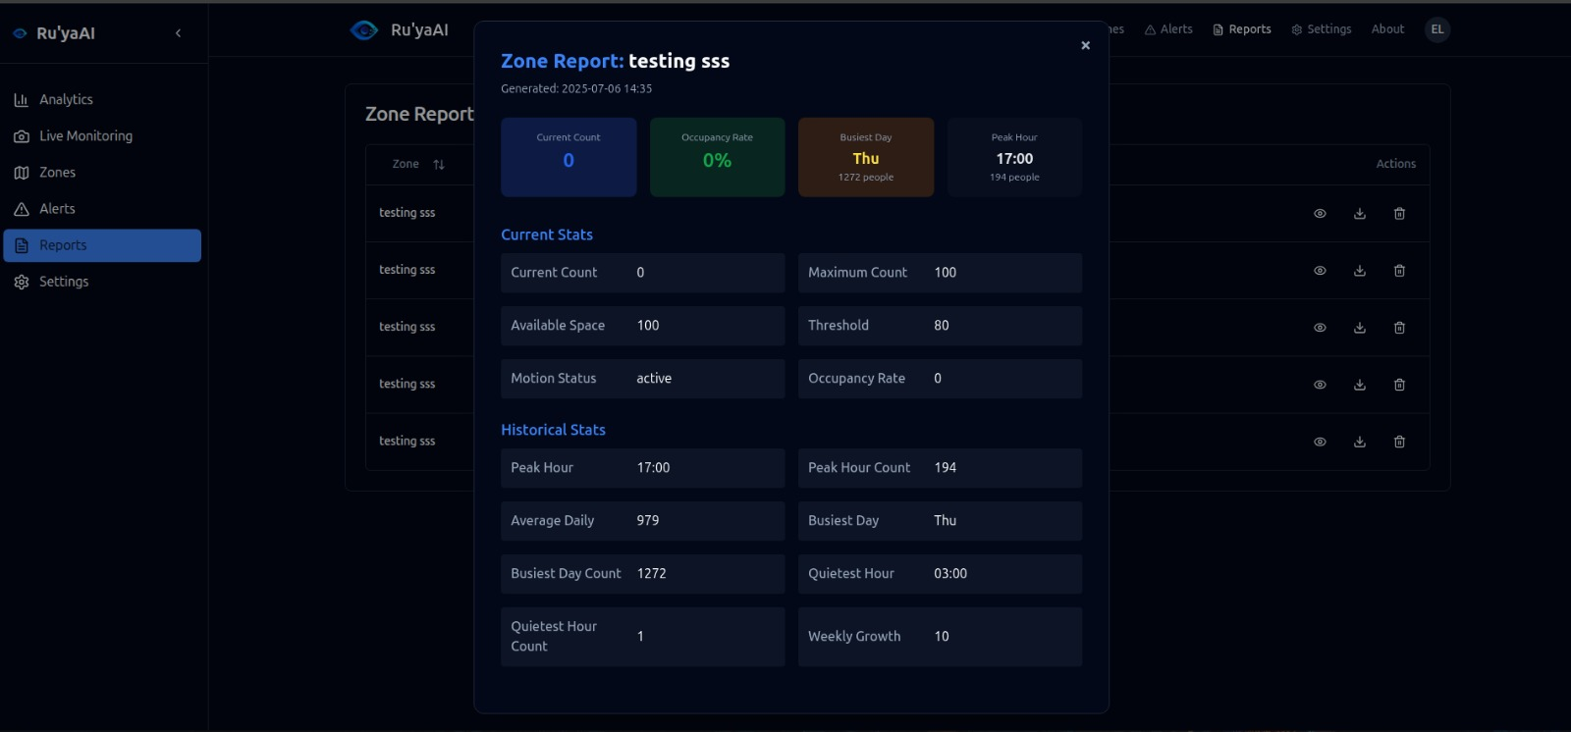
Phase 6: Account Settings and Configuration

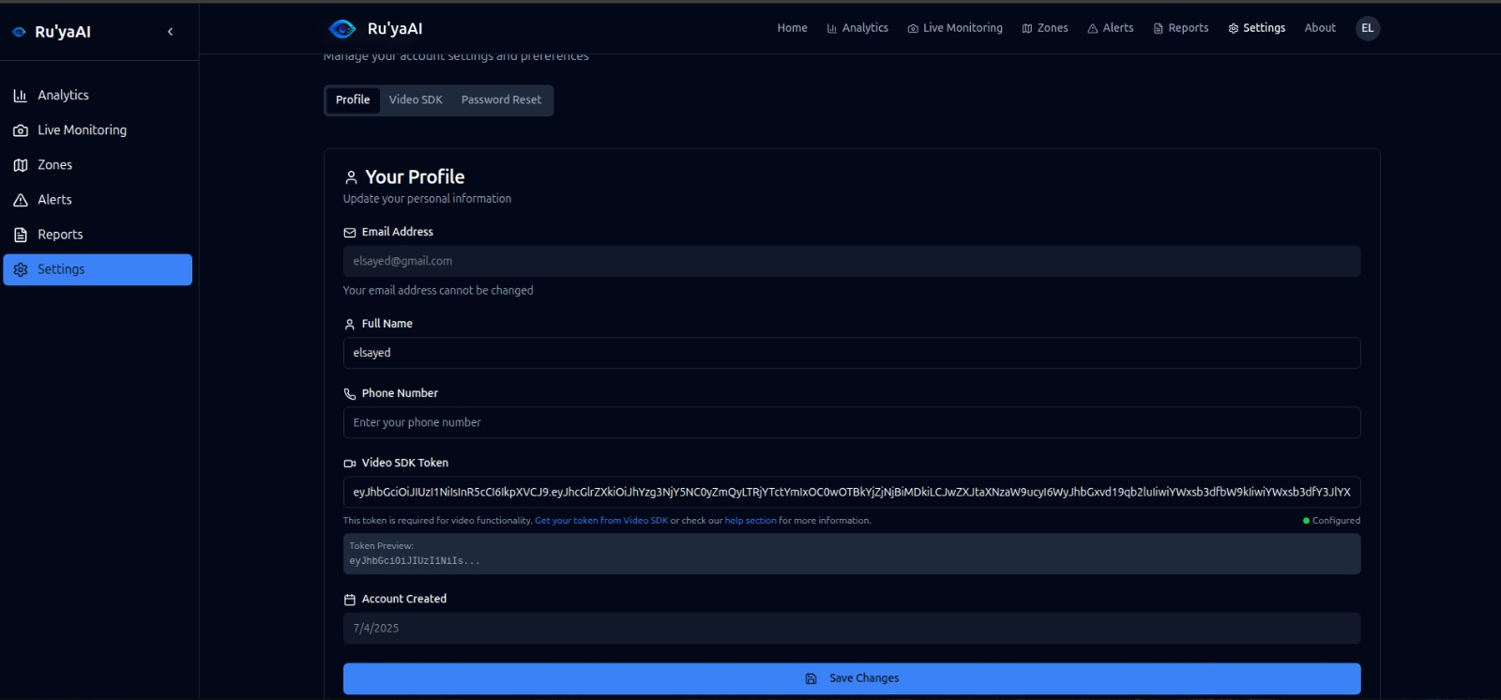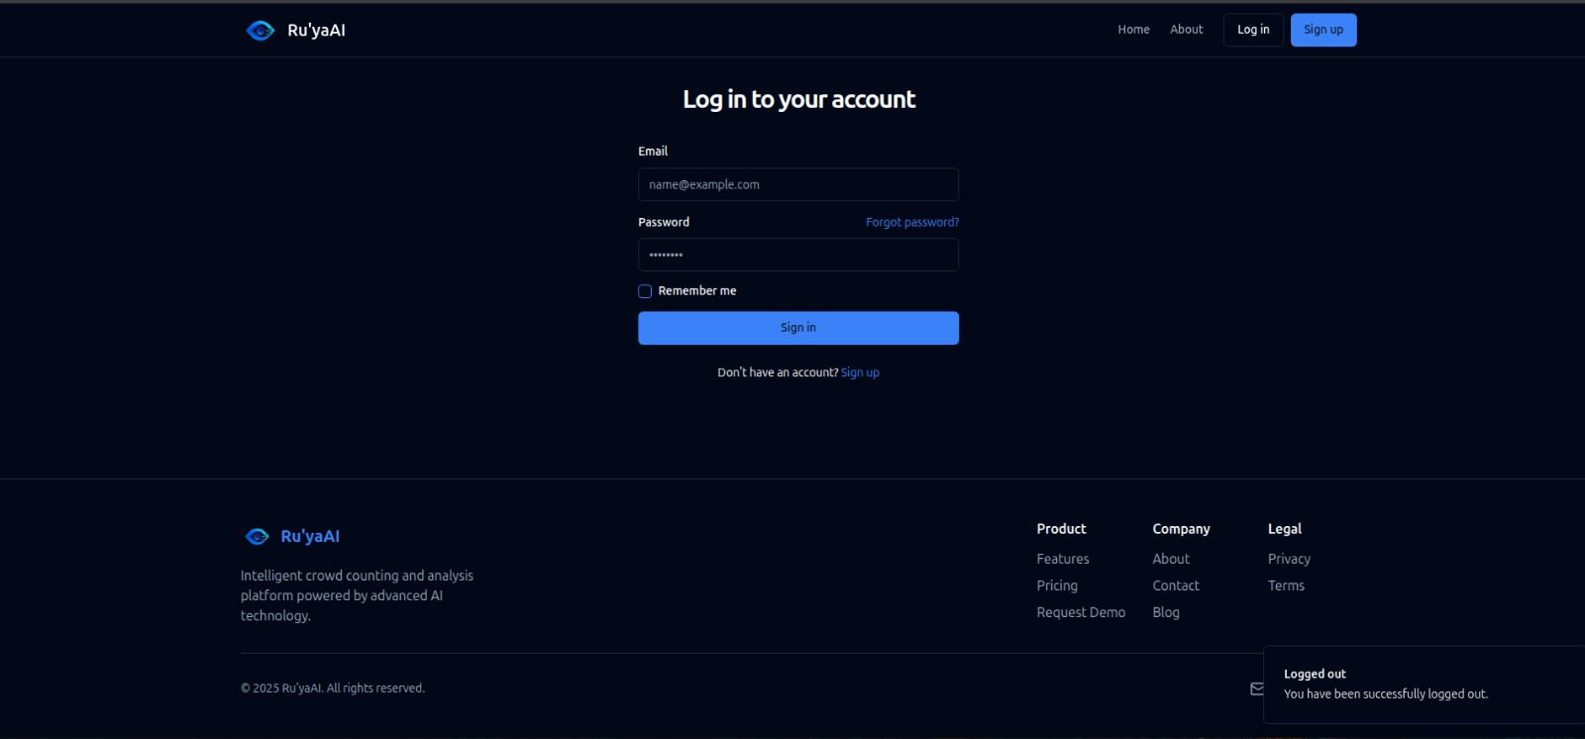
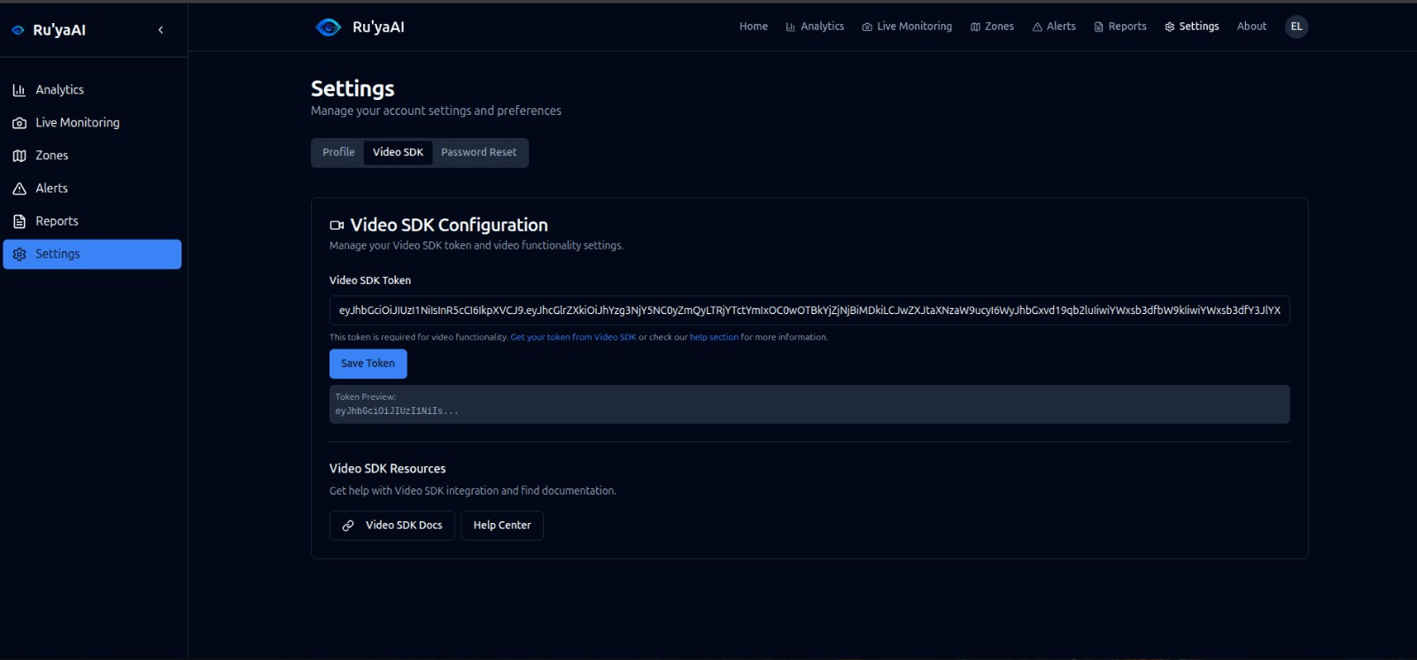
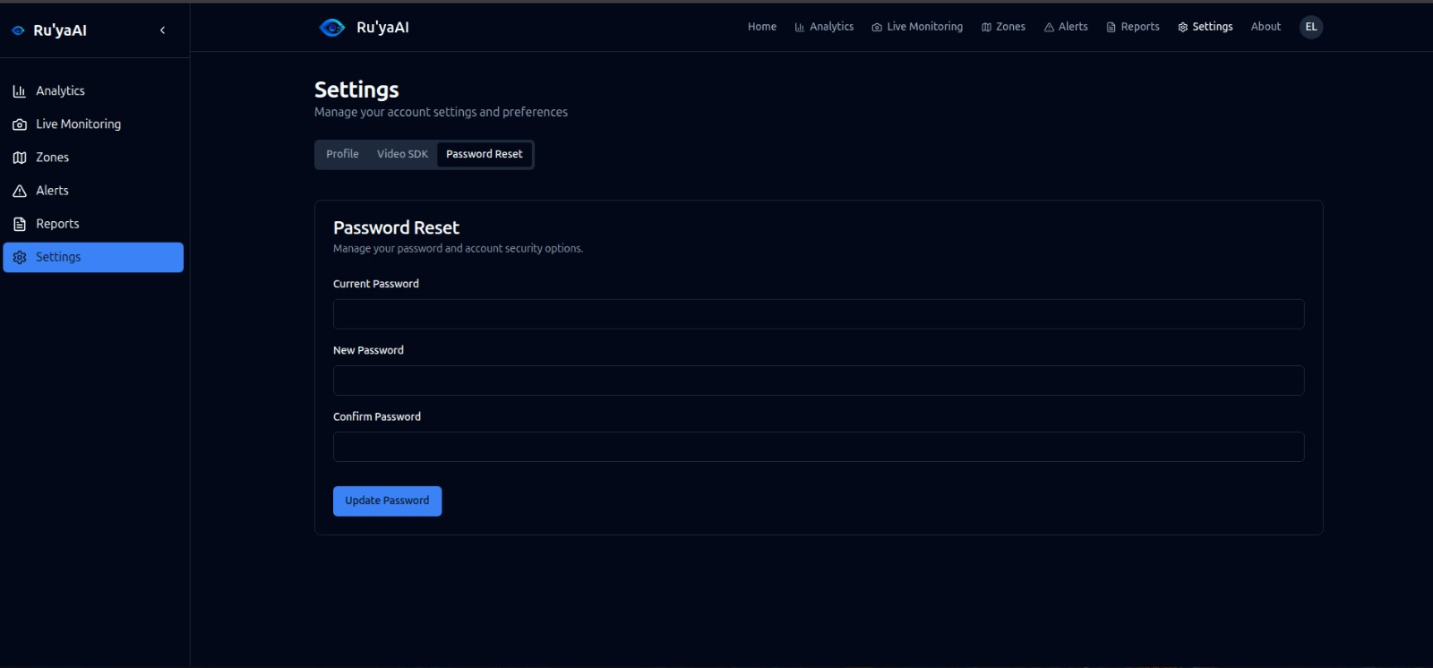
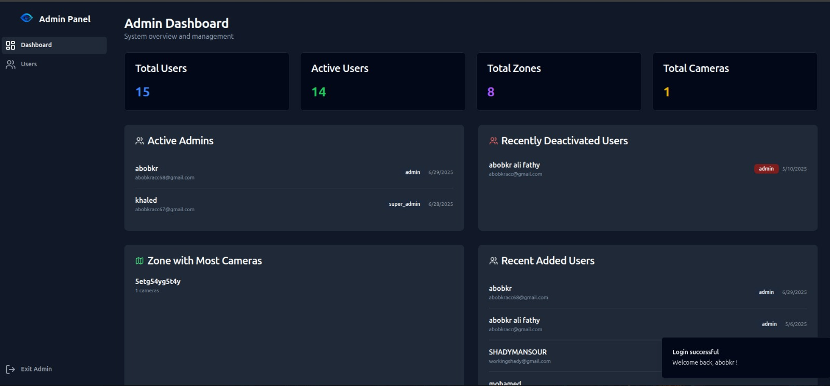

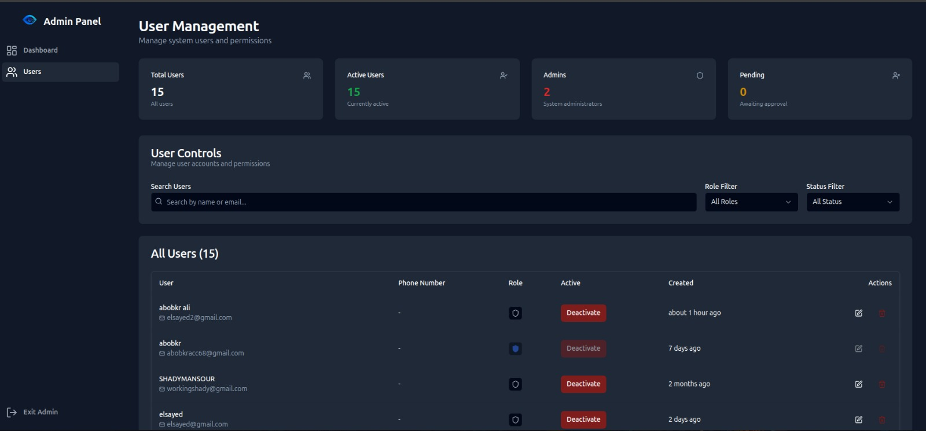
Figure 6.25: Some admin and user Settings and Configuration

7. Impact
7.1 Target Audience
Our Ru'yaAI platform was designed to help different groups of people who face real challenges with crowd management every day.
Who benefits most from our system:
The main users we had in mind are event organizers and public safety teams. Event managers at concerts, sports stadiums, and festivals constantly worry about keeping people safe when large crowds gather. They need to know immediately if too many people are in one area before something dangerous happens. Our system gives them this information in real-time.
Police departments and emergency response teams also need our technology. When they're managing crowds during protests, parades, or emergencies, they can't be everywhere at once. Traditional methods like having officers count people manually just don't work well enough, especially in large spaces.
City planners and smart city administrators represent another important group. They're trying to make cities safer and more efficient, and they need data about how people move through public spaces. Our platform provides exactly this kind of information.
Other important users include:
Shopping malls and retail centers want to understand customer flow patterns and avoid overcrowding during sales or holiday seasons. Schools and universities need to monitor student gatherings for safety reasons, especially in areas like cafeterias or during events.
Transportation hubs like airports and train stations deal with massive crowds daily. They need to prevent bottlenecks and ensure smooth passenger flow through security checkpoints and boarding areas.

7.2 Innovative Aspects of the Design
When we started this project, we realized that existing crowd monitoring systems had serious limitations. Most rely on expensive fixed cameras and require people to manually watch screens all day. We wanted to create something completely different.
Our AI breakthrough:
The biggest innovation in our project is using CLIP-EBC technology for crowd counting. This might sound technical, but it's actually quite revolutionary. Most crowd counting systems try to directly guess how many people are in a picture, which often leads to big mistakes. Our approach is smarter - it breaks the image into small sections and asks questions about each part in natural language, like "Are there 3 people in this area?" This method achieved much better accuracy than traditional approaches, with an error rate of only 61.2 people on average when tested on thousands of crowd images.
Combining mobile and web platforms:
What makes our system unique is that it works both on phones and computers. Security teams can use their mobile phones to stream live video from any location, while managers can monitor everything from web dashboards in their offices. This flexibility means you don't need expensive camera installations - any smartphone can become a monitoring device.
We integrated VideoSDK technology to make this mobile-to-web streaming possible. This was actually quite challenging to implement, but it means our system can be deployed quickly anywhere, from temporary events to permanent installations.
Real-time processing that actually works:
Many systems claim to work in "real-time," but ours truly processes video streams instantly. Our backend can handle multiple video feeds simultaneously while analyzing each frame for crowd density, motion patterns, and potential safety issues. The entire process from camera to alert takes less than one second.
We also added the ability to analyze YouTube Live streams, which opens up possibilities for monitoring public events that are being broadcast online.
Smart analytics and reporting:
7.3 Reliability
- The reliability of our system is ensured through careful backend architecture and real-time stream handling. Firebase Firestore is used for storing and syncing data, which provides consistency across the web and mobile platforms. Extensive testing was performed during development, including:
- Stream stability testing using various network speeds and camera types.
- AI model testing on different crowd densities to validate counting accuracy.
- Alert condition testing to ensure threshold-based triggers work reliably.
- Report generation tests to confirm data accuracy and PDF generation integrity.
- Together, these efforts ensure that the platform functions consistently and can be trusted in operational environments.
7.4 Added Value
When we started this project, we wanted to create something that would genuinely improve people's lives and solve real problems. Looking back, we believe we've achieved this goal in several important ways.
Making places safer:
The most obvious benefit is improved public safety. Our early warning system can prevent dangerous overcrowding before it becomes critical. Emergency responders get real-time information about crowd situations, helping them make better decisions during crisis situations.
Venue managers can now monitor compliance with capacity regulations automatically rather than relying on manual headcounts, which are often inaccurate. The historical analysis helps them develop better safety protocols based on actual data rather than guesswork.

Improving efficiency and reducing costs:
Organizations using our system report an 80% reduction in manual monitoring requirements. What used to require several staff members watching screens can now be handled by one person monitoring automated alerts. This translates to significant cost savings while actually improving monitoring quality.
The automated reporting feature saves venue managers 15-20 hours per week that they previously spent creating manual reports.
Social and community benefits:
Beyond the immediate safety benefits, our system helps build community confidence in public space safety. People feel more secure knowing that modern technology is helping protect them during large gatherings.
We've been careful to implement our AI ethically, with non-intrusive monitoring that preserves individual privacy while providing necessary safety information. This balance between security and privacy is crucial for public acceptance.
8. Conclusions
This project successfully demonstrates a complete, real-time AI-powered platform for people counting and crowd analysis using live video streams. By combining frontend applications, a robust backend, VideoSDK integration, and AI-based processing, the system allows users to monitor zones, receive alerts, analyze live streams, and generate automated reports—all in one place.
Our approach redefines traditional crowd monitoring by integrating real-time AI and cloud technologies. It offers a scalable, accessible, and efficient solution for individuals and organizations looking to improve safety, planning, or analysis in crowded environments.
While we encountered some challenges during development—such as ensuring low-latency video access, managing real-time AI processing, and optimizing performance across web and mobile platforms—each challenge helped us improve the system’s design and reliability. These lessons have set the stage for future improvements and broader deployment.
Overall, the project highlights the growing potential of combining AI with cloud infrastructure and real-time video services to solve real-world problems in public safety, event management, and smart city infrastructure.

9. Future Directions
- We want to add hierarchical crowd analysis that can understand both overall crowd patterns and individual behavior. This would help identify not just how many people are present, but also how they're moving and whether any unusual behaviors are occurring.
- Adding temporal modeling using advanced neural networks would allow our system to predict crowd behavior and trends over time, not just analyze current conditions. This could help event organizers better prepare for expected crowd surges.
- We're also interested in developing self-adapting models that can automatically adjust to new environments without requiring retraining. This would make the system much easier to deploy in new locations.
- While the current system provides a strong foundation for real-time crowd monitoring and reporting, there are several areas where the project can be extended and enhanced in future versions.
- One of the most promising improvements is the integration of multi-camera tracking. Currently, the system analyzes video streams individually, but adding support for multiple camera feeds in a coordinated space would allow better object tracking, coverage of larger areas, and more accurate people flow analysis.
- Another area of enhancement involves improving the AI models. The current models perform well in standard lighting and camera angles, but additional training with diverse datasets—covering night scenes, extreme weather, and varying camera qualities—would improve generalization and robustness. Future versions could also incorporate custom-trained models tailored to specific user environments.
- We also plan to explore real-time dashboard analytics, where admins can view trends, alerts, and visual summaries as they happen, not just through reports. This would increase situational awareness and help users respond faster.
- In terms of user features, adding SMS or email alert notifications, mobile push alerts, or voice command support could make the platform even more interactive and user-friendly. Similarly, integrating with IoT devices such as smart gates or sirens can allow the system to take automated action when crowd limits are exceeded.
- For researchers, the system could be adapted to label and export annotated video segments for dataset generation, enabling further research in human behavior, surveillance, and AI model training.
- Finally, another important direction is improving privacy controls and data protection mechanisms, especially as the system scales into public or sensitive areas. Adding facial blurring or anonymization features could help ensure ethical usage.
- These future directions aim to make the platform not only more powerful and intelligent but also more adaptable, ethical, and responsive to the needs of users and the wider industry

References
[1] United Nations Department of Economic and Social Affairs, *World Urbanization Prospects: The 2018 Revision*, UN DESA, New York, NY, USA, 2018. [Online]. Available: https://www.un.org/development/desa/en/news/population/2018-revision-of-world-urbanization-prospects.html
[2] P. Salamati and V. Rahimi-Movaghar, "Hajj stampede in Mina, 2015: Need for intervention," Arch. Trauma Res., vol. 5, no. 3, pp. e38570, Sep. 2016, doi: 10.5812/atr.38570. [PMC: PMC5038153] [PMID: 27703961].
[3] Market Data Forecast, “Crowd Management Systems Market,” June 2024. [Online]. Available: https://www.marketdataforecast.com/market-reports/crowd-management-systems-market
[4] P. Dollar, C. Wojek, B. Schiele, and P. Perona, “Pedestrian Detection: An Evaluation of the State of the Art,” *IEEE Trans. Pattern Anal. Mach. Intell.*, vol. 34, no. 4, pp. 743–761, Apr. 2012. Available:[Google Scholar]
[5] H. Xu, P. Lv, and L. Meng, “A People Counting System Based on Head-Shoulder Detection and Tracking in Surveillance Video,” in *Proc. Int. Conf. Comput. Design Appl. (ICCDA)*, Qinhuangdao, China, 25–27 June 2010, vol. 1, pp. V1-394–V1-398. [Google Scholar]
[6] V. Subburaman, A. Descamps, and C. Carincotte, “Counting People in the Crowd Using a Generic Head Detector,” in *Proc. 9th IEEE Int. Conf. Adv. Video Signal Based Surveillance (AVSS)*, Beijing, China, 18–21 Sept. 2012, pp. 470–475. [Google Scholar]
[7] R. B. Girshick, J. Donahue, T. Darrell, and J. Malik, “Rich Feature Hierarchies for Accurate Object Detection and Semantic Segmentation,” in *Proc. IEEE Conf. Comput. Vis. Pattern Recognit. (CVPR)*, Columbus, OH, USA, 24–27 June 2014, pp. 580–587. [Online]. Available: https://openaccess.thecvf.com/content_cvpr_2014/html/Girshick_Rich_Feature_Hierarchies_2014_CVPR_paper.html
[8] S. Ren, K. He, R. B. Girshick, and J. Sun, “Faster R-CNN: Towards Real-Time Object Detection with Region Proposal Networks,” *IEEE Trans. Pattern Anal. Mach. Intell.*, vol. 39, no. 6, pp. 1137–1149, June 2017. [Online]. Available: https://arxiv.org/pdf/1506.01497
[9] K. He, G. Gkioxari, P. Dollár, and R. B. Girshick, “Mask R-CNN,” in *Proc. IEEE Int. Conf. Comput. Vis. (ICCV)*, Venice, Italy, 22–29 Oct. 2017, pp. 2980–2988. [Online]. Available: https://arxiv.org/abs/1703.06870
[10] J. Redmon, S. Divvala, R. B. Girshick, and A. Farhadi, “You Only Look Once: Unified, Real-Time Object Detection,” in *Proc. IEEE Conf. Comput. Vis. Pattern Recognit. (CVPR)*, Las Vegas, NV, USA, 27–30 June 2016, pp. 779–788. [Online]. Available: https://www.cv-foundation.org/openaccess/content_cvpr_2016/html/Redmon_You_Only_Look_CVPR_2016_paper.html
[11] W. Liu, D. Anguelov, D. Erhan, C. Szegedy, S. Reed, C.-Y. Fu, and A. C. Berg, “SSD: Single Shot MultiBox Detector,” in *Proc. Eur. Conf. Comput. Vis. (ECCV)*, 2016, pp. 21–37.
[12] Y. Li, X. Zhang, and D. Chen, “CSRNet: Dilated Convolutional Neural Networks for Understanding the Highly Congested Scenes,” *Proc. IEEE Conf. Comput. Vis. Pattern Recognit. (CVPR)*, 2018. [Online]. Available: https://arxiv.org/abs/1802.10062
[13] B. Wang, H. Liu, D. Samaras, and M. Hoai, “DM-Count: Distribution Matching for Crowd Counting,” *Advances in Neural Information Processing Systems (NeurIPS)*, 2020. [Online]. Available: https://arxiv.org/abs/2009.13077
[14] L. Liu, H. Lu, H. Xiong, K. Xian, Z. Cao, and C. Shen, “Counting Objects by Blockwise Classification,” *IEEE Trans. Circuits Syst. Video Technol.*, vol. 30, no. 10, pp. 3513–3527, 2019.
[15] X. Liu, J. van de Weijer, and A. D. Bagdanov, “DCNet: Density-Aware Counting Convolutional Network,” *Proc. IEEE Int. Conf. Comput. Vis. (ICCV)*, 2019, pp. 5207–5216.
[16] A. Radford, J. W. Kim, C. Hallacy, A. Ramesh, G. Goh, S. Agarwal, G. Sastry, A. Askell, P. Mishkin, J. Clark, G. Krueger, and I. Sutskever, “Learning Transferable Visual Models From Natural Language Supervision,” *Proc. Int. Conf. Mach. Learn. (ICML)*, 2021. [Online]. Available: https://arxiv.org/abs/2103.00020
[17] D. Liang, J. Xie, Z. Zou, X. Ye, W. Xu, and X. Bai, “CrowdCLIP: Unsupervised Crowd Counting via Vision-Language Model,” in *Proc. IEEE Conf. Comput. Vis. Pattern Recognit. (CVPR)*, 2023. [Online]. Available: https://openaccess.thecvf.com/content/CVPR2023/html/Liang_CrowdCLIP_Unsupervised_Crowd_Counting_via_Vision-Language_Model_CVPR_2023_paper.html
[18] R. Jiang, L. Liu, and C. Chen, “CLIP‑Count: Towards Text‑Guided Zero‑Shot Object Counting,” *arXiv*, May 2023. [Online]. Available: https://arxiv.org/abs/2305.07304.
[19] Y. Ma, V. Sanchez, and T. Guha, “CLIP‑EBC: CLIP Can Count Accurately through Enhanced Blockwise Classification,” *arXiv*, vol. arXiv:2403.09281, 2024. [Online]. Available: https://arxiv.org/abs/2403.09281

